Rooftop Packaged Unit

Commercial AC R&D DepartmentⅠ
March, 2016
CONTENT
Engineering Data 1
1 Product List 1
2 Nomenclature 1
3 Features 1
3.1 General 1
3.2 Features 2
4 Technical Data 2
5 Operation Range 3
6. Capacity Correction 4
7 Outline Dimensions 5
8 Explosive Views and Part Lists 6
Design and Selection 8
1 Selection Steps 8
1.1 Basic Flowchart 8
2 Selection of Power Lines and Air Switches 10
2.1 Wiring 10
2.2 Selection of Power Lines and Air Switches 11
Unit Control 12
1 General Control Concept 12
1.1 Control Principle 12
1.2 Control Flowchart 12
2 Main Control Logic 16
2.1 Control to the Indoor Fan 16
2.2 Control to Defrosting 18
3 Controller 18
3.1 Appearance and Functions 18
3.2 DIP Switch 19
Unit Installation 20
1 Safety Precuations 20
1.1Precautions for Unloading 20
1.2Location of Air Grille/Diffusers 21
1.3Location of Air Grille/Diffusers 22
1.4Diagrams of Installation Drawings 27
1.5 Requirements on Installation Base 28
1.6 Installation of the Condensate Pipe 29
1.7 Installation of the Indoor Temperature Sensor 29
1.8Installation of the Control Panel 30
2 Required Tools for Instalation 30
3 Fabrication and Installation of Ducts 31
3.1 Precautions for Connection between Ducts and Air Grills/Diffusers 31
3.2 Fabrication of Metal Ducts 32
3.3 Fabrication of Compound Ducts 35
3.4 Requirements on Fabrication of Ducts 37
3.5 Fabrication of Plenums 38
3.6 Installation of the Duct System 38
3.6.1 Installation Flowchart 38
3.6.2 Fabrication and Installation of Hangers and Supporters 38
3.6.3 Regulations on Installation of Hangers and Supporters 40
3.6.4 Regulations on Installation of Hangers/Supporters of the Metal Duct 41
3.6.5 Installation of the Duct 41
3.6.6 Airtight Test to the Ducts 42
Test Opration & Troubleshooting & Maintenance 43
1 Commissioning 43
1.1 Checkup before Commissioning 43
1.1.1 Installation of the Unit 43
1.1.2 Electric 43
1.1.3 Duct 43
1.1.4 Drainage 43
1.2 Commissioning 43
1.2.1Removal of Impurity inside the Duct 43
1.2.2 Cooling during Commissioning 43
1.2.3 Heating during Commissioning 44
2 Error List 44
3 Typical Troubleshooting 48
3.1 Compressor High Pressure Protection 48
3.2 Compressor Low Pressure Protection 49
3.3 Filter Pressure Differential Protection 54
4 Maintenance to Main Components 55
4.1 Requirements on Maintenance 55
4.2 Maintenance to Main Components 56
4.2.1Maintenance to the Fan 56
4.2.2Maintenance to the Fins 57
4.2.3Maintenance to the Filter 58
5 Replacement of Components 58
5.1 Replacement of the Fan Bearing 58
5.2 Replacement of the Motor Bearing 65
5.3 Lubricating 76
5.3.1 Principles for Lubricating 76
5.3.2. Lubricating Steps 77
6 Operation Conditions 78

Engineering Data

1 Product List
Model | Product Code | Cooling Capacity (Ton) | Heating Capacity (Ton) | Refrigerant | Power Supply | Appearance
WKR105/NaA-M | EJ51000570 | 30 | 31 | R410A | 380V 3Ph 50Hz | 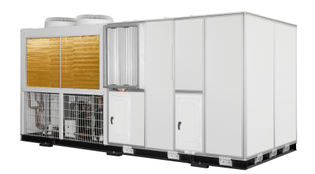
WKR140/NaA-M | EJ51000490 | 40 | 43
WKR180/NaA-M | EJ51000560 | 51 | 51
WKR230/NaA-M | / | 65 | 68 |  |  | 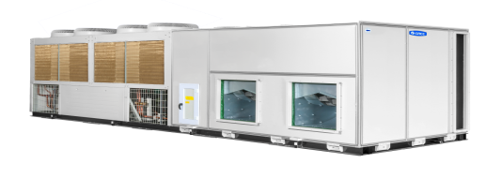
WKR280/NaA-M | EJ51000580 | 80 | 82
WKR370/NaA-M | EJ51000480 | 104 | 105
Note: pictures listed in the table are just for reference.

2 Nomenclature
WK | R | ＿ | /Na | A | －M
1 | 2 | 3 | 4 | 5 | 6

No | Description | Options
1 | Type | WK: Rooftop air conditioning
2 | Function | R: heat pump; default: cooling only
3 | Cooling capacity | Rated cooling capacity, unit: kW
4 | Refrigerant type | Na－R410a
5 | Design code | A: A series
6 | Power supply | M:3Ph,380V,50Hz

3 Features

3.1 General
The rooftop air conditioning is such a kind of air conditioning that can realize cooling in summer and heating in winter. It features with easy operation, and low installation and maintenance cost. It has been more and more widely used in the air conditioning projects.
The rooftop air conditioning unit requires no cooling tower and cooling water pump, which is especially applicable for water-deficient area. Also, this unit requires no machine room. It can be installed either at the rooftop or the outdoor ground. It is mainly applicable to air conditioning of large-size buildings, like exhibition halls, stadiums, theaters, supermarkets, waiting rooms, meeting rooms, workshops, libraries etc.
This product is a combination of the high-efficiency scroll compressor, low-noise axial fan, high-precision electrostatic expansion valve, and the advanced control system etc.

3.2 Features
High efficiency | High stability and reliability | Low noise | Smart control | Compact design | Easy operation | Easy maintainability

4 Technical Data
Model |  |  |  | WKR105/NaA-M | WKR140/NaA-M |  | WKR180/NaA-M
Product Code |  |  |  | EJ51000570 | EJ51000490 |  | EJ51000560
Data | Cooling capacity |  | kW | 105 | 140 |  | 180
 | Heating capacity |  | kW | 110 | 150 |  | 180
 | Cooling power |  | kW | 41.5 | 52.5 |  | 72
 | Heating power |  | kW | 41.5 | 52.5 |  | 72
 | Air volume |  | m³/h | 18900 | 25200 |  | 31000
 | External static pressure |  | Pa | 400 | 480 |  | 400
 | Non-standard static pressure range |  | Pa | 150~600 | 150~600 |  | 150~600
 | Supply fan |  |  | Front curved multiblade fan |  |  | Backward single-blade centrifugal fan
 | Fan power |  | kW | 11 |  | 15 | 15
 | Power supply |  |  | 380V 3N～ 50Hz
 | Safety devices |  |  | High/low pressure switch, anti-freeze switch, over-current protection switch, phase protector, overload protector etc.
 | Compressor type |  |  | High-efficiency scroll compressor
 | Compressor quantity |  |  | 2 |  | 2 |  | 2
 | Evaporator type |  |  | High-efficiency finned coil
 | Condenser type |  |  | High-efficiency finned coil
 | Outline dimensions | W | mm | 4680 |  | 4680 |  | 5370
 |  | D | mm | 2100 |  | 2100 |  | 2200
 |  | H | mm | 2310 |  | 2310 |  | 2510
 | Net weight |  | kg | 2360 |  | 2630 |  | 3380

Model |  |  |  | WKR230/NaA-M | WKR280/NaA-M | WKR370/NaA-M
Product Code |  |  |  | / | EJ51000580 | EJ51000480
Data | Cooling capacity |  | kW | 230 | 280 | 365
 | Heating capacity |  | kW | 240 | 290 | 370
 | Cooling power |  | kW | 82 | 100 | 125
 | Heating power |  | kW | 82 | 100 | 125
 | Air volume |  | m³/h | 40000 | 50000 | 63000
 | External static pressure |  | Pa | 400 | 400 | 400
 | Non-standard static pressure range |  | Pa | 200~600 | 200~600 | 200~600
 | Supply fan type |  |  | Backward single-blade centrifugal fan
 | Fan power |  | kW | 15 | 18.5 | 22
 | Power supply |  |  | 380V 3Ph 50Hz
 | Safety devices |  |  | High/low pressure switch, anti-freeze switch, over-current protection switch, phase protector, overload protector etc.
 | Compressor type |  |  | High-efficiency scroll compressor
 | Compressor quantity |  |  | 4 | 4 | 4
 | Evaporator type |  |  | High-efficiency finned coil
 | Condenser type |  |  | High-efficiency finned coil
 | Outline dimensions | W | mm | 7750 | 7750 | 8580
 |  | D | mm | 2100 | 2100 | 2200
 |  | H | mm | 2510 | 2510 | 2510
 | Net weight |  | kg | 4370 | 4680 | 5330
Notes:
- This product should comply with the national standard GB/T 20738-2006.
- Rated conditions
Cooling: outdoor temperature 35℃DB/24℃WB, indoor temperature 27℃DB/19℃WB；
Heating: outdoor temperature 7℃DB/6℃WB, indoor temperature 20℃DB/15℃WB
- This product will change for improvement. Therefore, please date listed on the nameplate always prevail.

5 Operation Range
Item | Indoor air side | Outdoor air side
 | Environment DB Temp (℃) | Environment DB Temp (℃)
Cooling | 16~30 | 18~48
Heating | 16~30 | -15~24
Note: when operation conditions are out of the range listed above, please contact the manufacturer.

6. Capacity Correction
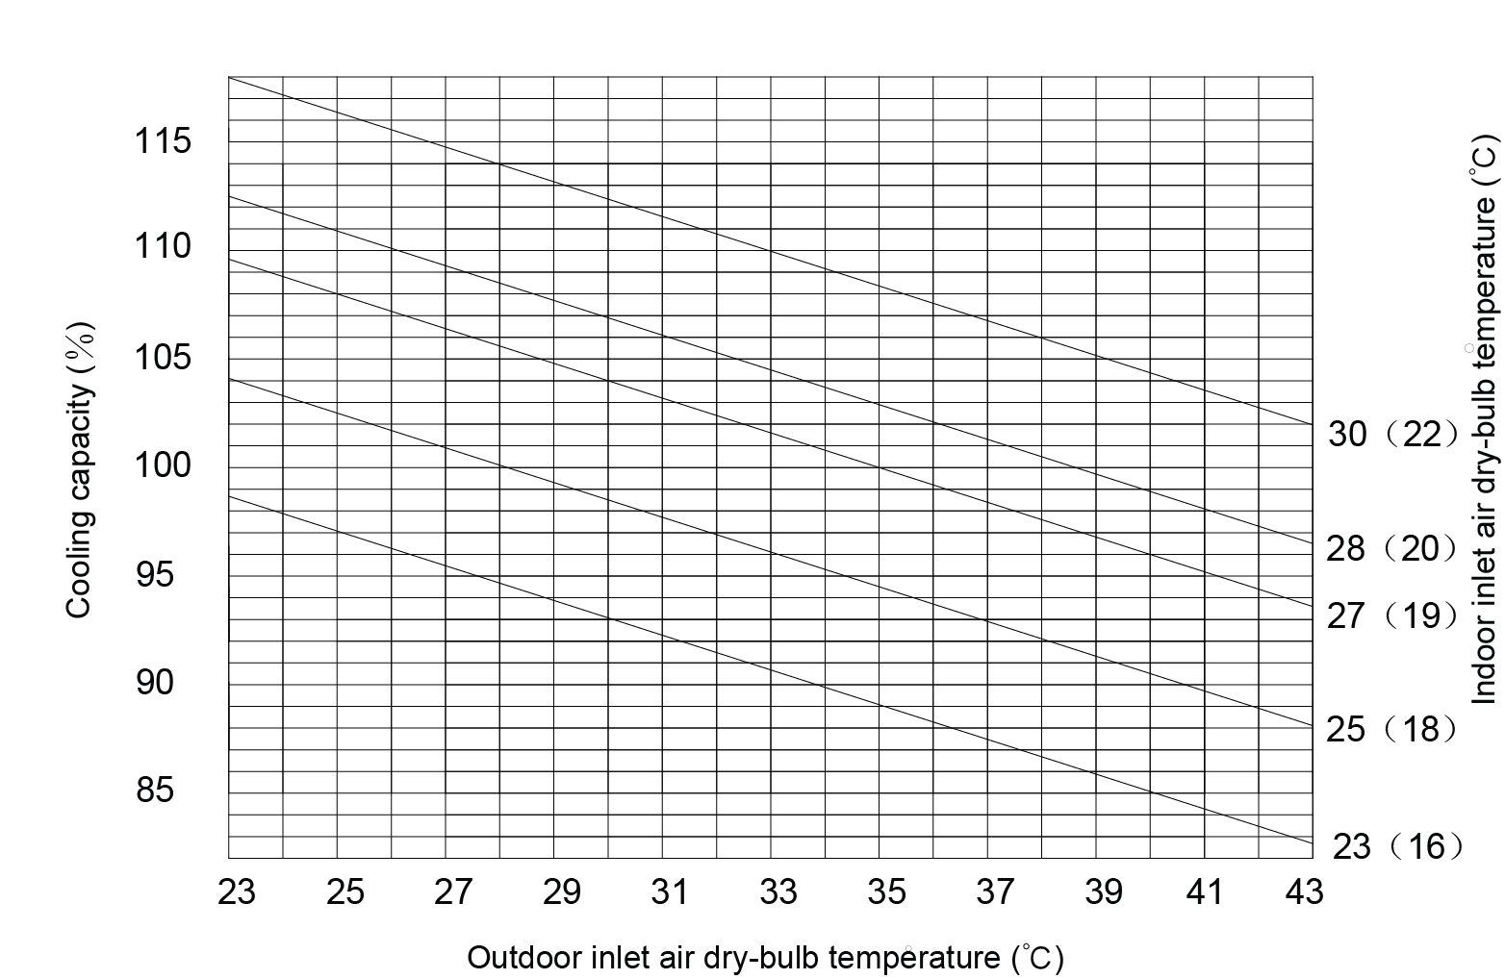
Cooling Capacity Correction Curves
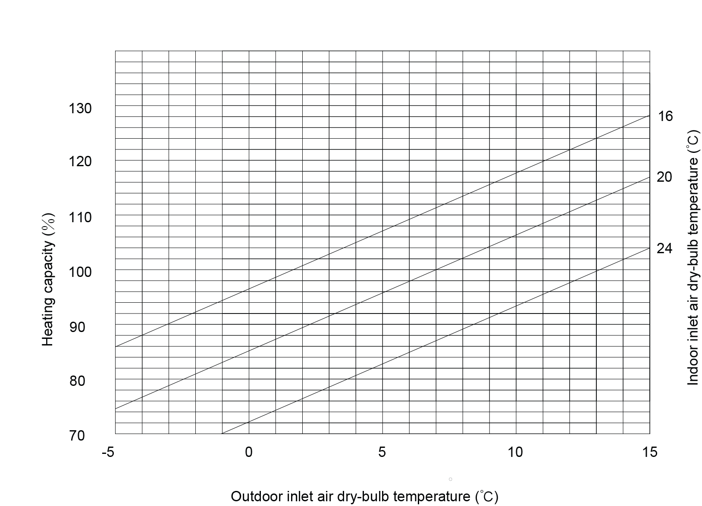
Heating Capacity Correction Curve

7 Outline Dimensions
WKR105/NaA-M, WKR140/NaA-M, WKR180/NaA-M, WKR230/NaA-M, WKR280/NaA-M, WKR370/NaA-M (unit: mm)
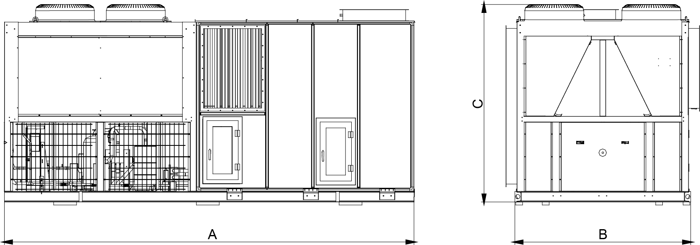
Note: position of the air outlets are just for reference.
Model | A | B | C
WKR105/NaA-M | 4680 | 2100 | 2310
WKR140/NaA-M | 4680 | 2100 | 2310
WKR180/NaA-M | 5370 | 2200 | 2510
WKR230/NaA-M | 7750 | 2100 | 2510
WKR280/NaA-M | 7750 | 2100 | 2510
WKR370/NaA-M | 8580 | 2200 | 2510

8 Explosive Views and Part Lists
WKR140/NaA-M
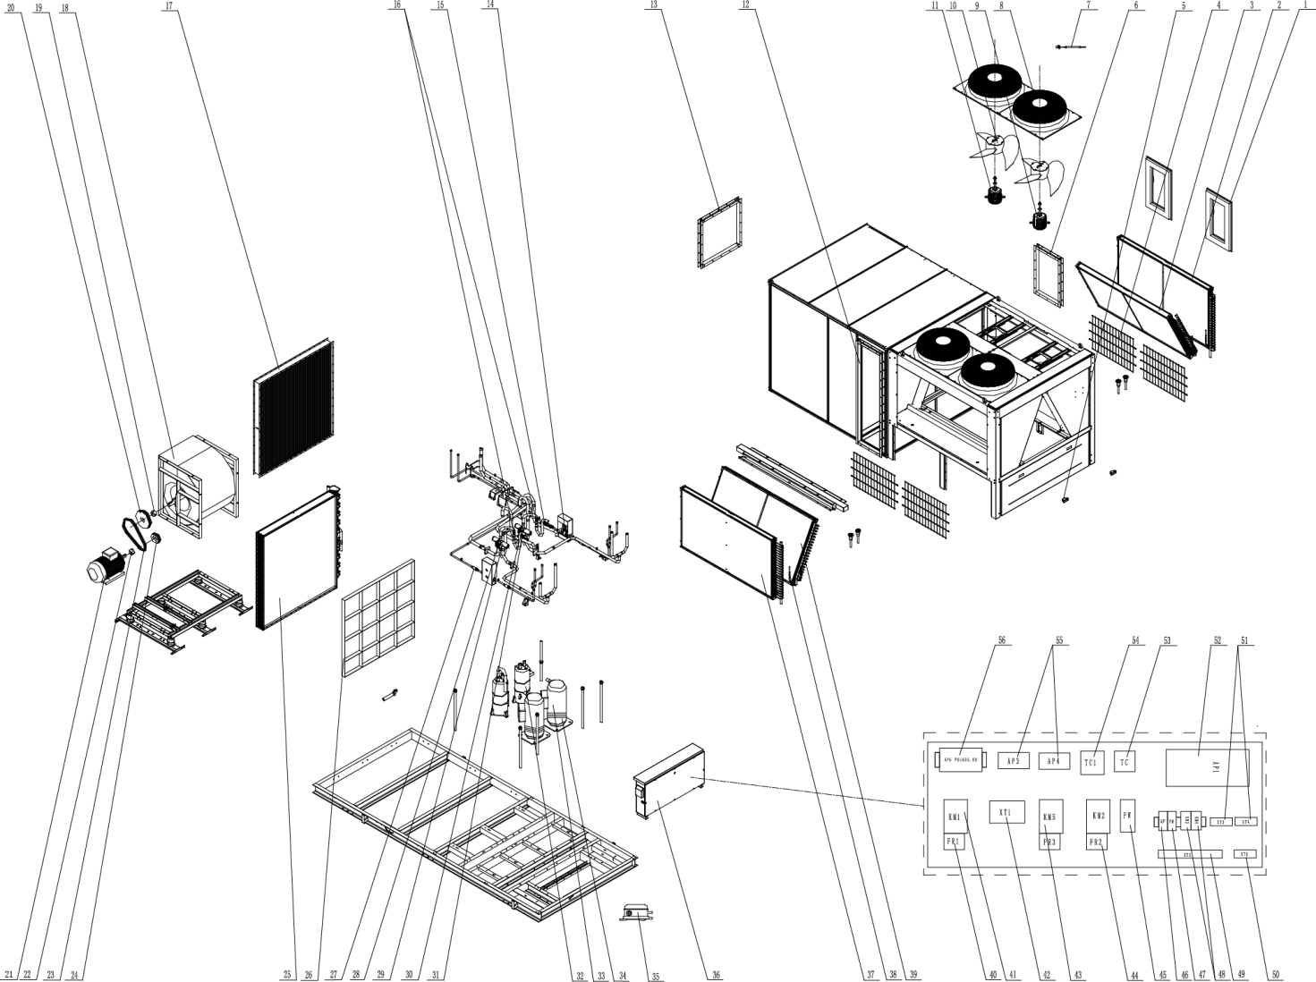

No. | Material Name | Material Code | Quantity
1 | Overhaul Door Sub-assy | 0139600103701 | 2
2 | Condenser Assy 2 | 0112390002101 | 1
3 | Condenser Assy 4 | 0112390002001 | 1
4 | Rear Grill | 01573900009 | 4
5 | Handle | 26235253 | 2
6 | Flange sub-assy | 0149600004807 | 1
7 | Sensor Sub-assy | 39003900001G | 1
8 | Streamlined Dome | 22265801 | 4
9 | Fan Motor | 1570110000301 | 2
10 | Centrifugal Fan | 10355801 | 4
11 | Fan Motor | 15701100003 | 2
12 | Flange sub-assy | 01493900064 | 1
13 | Flange sub-assy | 0149671209 | 1
14 | Electronic Expansion Valve | 43048000004 | 1
15 | Pressure Protect Switch | 4602001575 | 1
16 | Pressure Protect Switch | 4602001559 | 2
17 | Breakwater Sub-Assy | 0135390005402 | 1
18 | Motor for Centrifugal Fan | 10456000007 | 1
19 | Taper Sleeve | 10548226 | 1
20 | Belt Wheel | 10548167 | 1
21 | Fan Motor | 15706000022 | 1
22 | Taper Sleeve | 10548227 | 1
23 | Belt | 76416058 | 3
24 | Belt Wheel | 10548170 | 1
25 | Evaporator Assy | 0102390002601 | 1
26 | Prefilter | 0741618012 | 6
27 | Strainer | 07413900026 | 4
28 | Magnet Coil | 4300040048 | 1
29 | 4-Way Valve | 43041100017 | 2
30 | Magnet Coil | 4300040049 | 1
31 | Pressure Protect Switch | 4602001586 | 1
32 | Gas-liquid Separator | 07424142 | 2
33 | Compressor and Fittings | 00201100010 | 2
34 | Electrical Heater | 76518731 | 4
35 | Pressure Difference Switch | 46028251 | 1
36 | Electric Cabinet Assy | 01393900139 | 1
37 | Condenser Assy 1 | 0112390001801 | 1
38 | One Way Valve | 07130101 | 4
39 | Condenser Assy 3 | 0112390001901 | 1
40 | Thermal Relay | 4402037404 | 1
41 | AC Contactor | 44010240 | 1
42 | Terminal Board | 42010247 | 1
43 | AC Contactor | 44010239 | 2
44 | Thermal Relay | 44020383 | 2
45 | Power Panel | 30245000001 | 1
46 | Single-phase Air Switch | 45020203 | 1
47 | Phase Reverse Protector | 32214101 | 1
48 | AC Contactor | 44010232 | 2
49 | Terminal Board | 42010249 | 1
50 | Terminal Board | 42011255 | 1
51 | Terminal Board | 42018452 | 2
52 | Main Board | 30222000035 | 1
53 | Transformer | 4311030001 | 1
54 | Transformer | 43110012 | 1
55 | Main Board | 30221007 | 2
56 | DDC Controller | 49018000101 | 1

Design and Selection

1 Selection Steps

1.1 Basic Flowchart
Calculate load (cooling load and fresh air load) for each separate space→ Select the terminal unit → Select the main unit → Recalculate the heating and cooling load → make a confirmation
(1) Calculation of Load
1) Cooling Load per Unit Air Conditioning Area
Building Type | Room Type |  | Cooling Load (W/m²) | Building Type | Room Type | Cooling Load (W/m²)
Hotel | All |  | 70～95 | Hospital | All | 105～130
 | Guest Room |  | 70～100 |  | VIP Ward | 80～120
 | Cafe |  | 80～120 |  | General Ward | 70～110
 | Dining Room (Western Food) |  | 100～160 |  | Diagnostic Room | 75～140
 | Dining Room (Chinese Food) |  | 150～250 |  | X-ray, CT, MRT Room | 90～120
 | Store |  | 80～110 |  | Delivery Room | 100～150
 | Service Hall |  | 80～100 |  | Clean Operation Room | 180～380
 | Atrium |  | 100～180 |  | Hall | 70～120
 | Small Meeting Room |  | 140～250 | Shopping Mall | First Floor | 160～280
 | Large Meeting Room(No smoking) |  | 100～200 |  | Intermediate Floor | 150～200
 | Hairdressing Room |  | 90～140 |  | Top Floor | 180～250
 | Gym |  | 100～160 |  | All Stores | 210～240
 | Bowling Alley |  | 90～150 | Cinema and Theatre | Auditorium | 180～280
 | Billiard Room |  | 75～110 |  | Lounge Smoking (Smoking) | 250～360
 | Swinging Pool |  | 160～260 |  | Boudoir | 80～120
 | Ball Room |  | 180～220 |  | Hall and WC | 70～100
 | Disco |  | 220～320 | Stadium | Arena | 100～140
 | Karaoke |  | 100～160 |  | VIP Room | 120～180
 | Office |  | 70～120 |  | Lounge Room (Smoking) | 280～360
 | WC |  | 80～100 |  | Lounge Room (No Smoking) | 160～250
Bank | Service Hall |  | 120～160 |  | Rest Room | 100～140
 | Office |  | 70～120 | Office Building | VIP Office | 120～160
 | Machine Room |  | 120～160 |  | General Office | 90～120
Museum |  |  | 150～200 |  | Machine Room | 100～140
Auditorium |  |  | 160～240 |  | Meeting Room | 150～200
Multi-functional Room |  |  | 180～250 |  | Lounge Hall (Smoking) | 180～260
Library | Reading Room | 100～160 |  | Office Building | Hall and WC | 70～110
 | Hall | 90～110 |  |  | General Office | 95～115
 | Stack Rom | 70～90 |  |  | High-rise Office | 105～145
 | Special Collection Room | 100～150 |  | Apartment | Multi-layer Building | 88～150
Restaurant | Hall | 200～280 |  |  | High-rise Building | 80～120
 | VIP Room | 180～250 |  |  | Villa | 150～220
Supermarket | Hall | 160～220
 | Meat and Fish Room | 90～160
Note: it is cited from the Practical Design Manual for the Cooling and Heating Air Conditioners.
2) Estimated Heating/Cooling Load for Different Buildings
Building Type |  |  | Heating/Cooling Load (W/m²) |  |  |  | Indoor Heating/Cooling Load Conditions
 |  |  | Total cooling | Fresh Air | Total Heating | Fresh Air | Lighting (W/m²) | Occupant (p/m²) | Fresh Air (m³/m²h) | Permeated Air (h-1)
Bank | Business hall |  | 242 | 72 | 220 | 90 | 50 | 0.30 | 6 | 1.5
 | Reception room |  | 179 | 48 | 184 | 59 | 30 | 0.20 | 4 | 0.5
Department Store | First floor |  | 355 | 97 | 246 | 107 | 80 | 0.80 | 8 | 2.0
 | Speciality Stores |  | 307 | 121 | 161 | 134 | 60 | 1.00 | 10 | 0.5
 | Stores |  | 217 | 97 | 137 | 107 | 60 | 0.40 | 8 | 0.5
Supermarket | Food |  | 212 | 72 | 195 | 80 | 60 | 0.60 | 6 | 0.5
 | Costume |  | 215 | 72 | 167 | 80 | 60 | 0.30 | 6 | 0.5
Hotel | Banquet room |  | 449 | 260 | 312 | 299 | 80 | 1.00 | 20 | 0
 | Guest room | S | 127 | 78 | 207 | 90 | 20 | 0.12 | 6 | 0.5
 |  | W | 131 |  | 207 |  | 20 | 0.12 | 6 | 0.5
 |  | N | 125 |  | 207 |  | 20 | 0.12 | 6 | 0.5
 |  | E | 130 |  | 207 |  | 20 | 0.12 | 6 | 0.5
Eating House | Dining room |  | 286 | 144 | 228 | 179 | 40 | 0.60 | 12 | 0.5
Community Center | Study room |  | 233 | 121 | 228 | 149 | 20 | 0.50 | 10 | 0.5
Library | Reading room |  | 143 | 48 | 125 | 59 | 30 | 0.20 | 4 | 0.5
Hospital | Ward No.6 | S | 91 | 48 | 112 | 59 | 15 | 0.20 | 4 | 0.5
 |  | W | 110 |  | 112 |  | 15 | 0.20 | 4 | 0.5
 |  | N | 79 |  | 112 |  | 15 | 0.20 | 4 | 0.5
 |  | E | 96 |  | 112 |  | 15 | 0.20 | 4 | 0.5
Theater | Auditorium |  | 512 | 362 | 506 | 448 | 25 | 1.50 | 30 | 0
 | Hall |  | 237 | 78 | 219 | 90 | 30 | 0.30 | 6 | 0.5
3) Estimated Cooling Load Index per Square Meter of Building Area
Building Type | Cooling Load Index (W/m²) | Cooling Load Index (W/m²)
Hotel | 35~45 | 70~81
Large Hall | 56~72 | /
Office Building | 42~54 | 84~98
Library, Museum | 18~32 | 35~41
Department Shops | 25~59 | 56～65  (air conditioning is available only for the service hall)
Gym | 35~135 | 209～244  (as per the gym area)
105～122
(as per the total building area)
Cinema | 42~68 | 84～98  (air conditioning is available only for the service hall)
Theatre | / | 105~128
Hospital | 28~45 | 58~81
Restaurant | / | 105~116
Notes:
- This table is cited from HVAC Design and Usual Troubleshooting.
- When the total building area is less than5000m², take the upper limit; when it is larger than 10000m², take the lower limit.
- The cooling load index in this table indicates the cooling capacity and no coefficient is required.
- Unless noted specially, total building area is taken into considering in any case.
(2) Calculation of Indoor Load
Required Cooling Load(W)= Room Area (m2)×Unit Load(W/m2)
Note: real conditions at the jobsite should be taken into consideration when selecting the load index.
(3) Selection of the Terminal Unit
Select a proper terminal unit in accordance with the calculated required cooling load, noise and installation space etc.
(4) Selection of the Main Unit
Select a proper main unit in accordance with the main unit and the utilization coefficient of 0.7~0.8. Two main units are always given priority. A backup is unnecessary (However, it can be prepared when required especially for the continuously-running system).
(5) Recheck of the Heat Load
It should be done only when there is requirement on heat load.
When three steps stated above have been finished, check if the heat load is satisfied. If not, select the terminal unit and the main unit in accordance with the heat load, and then check if the cooling load is satisfied. Do this step again until the cooling load is satisfied.
(6) Examples
Take a building covering 5000㎡ for example and fresh air is required.
- Calculate the cooling load as per the building area
5000×98W＝490kW
490×1.1=539KW
b．Calculate the heating load as per the building area
5000×54=270kW
c．Selection of the unit model and quantity
Refer to the Gree Sales Guide Manual and design requirements, 3 sets of WKR180/NaA rooftop packaged unit are selected.

2 Selection of Power Lines and Air Switches

2.1 Wiring
External Wiring Diagram
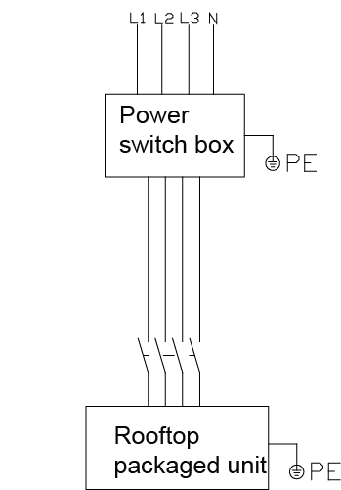
Note: please always see the wiring diagram attached to the unit for exact wiring.

2.2 Selection of Power Lines and Air Switches
Models | Power supply | Air switch and power line
 |  | Air switch  (A) | Live Line  (mm²) | Neutral and ground Line  (mm²)
WKR105/NaA-M | 3Ph,380V, 50Hz | 125 | 35 | 16
WKR140/NaA-M | 3Ph,380V, 50Hz | 150 | 50 | 25
WKR180/NaA-M | 3Ph,380V, 50Hz | 200 | 70 | 35
WKR230/NaA-M | 3Ph,380V, 50Hz | 250 | 95 | 50
WKR280/NaA-M | 3Ph,380V, 50Hz | 300 | 150 | 70
WKR370/NaA-M | 3Ph,380V, 50Hz | 350 | 240 | 120
Notes:
(1) For the power lines, the default unit is mm² and all lines are 5-core.
(2) Specifications of the power lines are figured out based on 40℃ environmental temperature and 90℃ of the temperature tolerance of the multi-core cupper lines laid inside the cable duct (see GB/T 16895.15). Once conditions changes, specifications should be adjusted as per national standards.
(3) Specifications of the air switch are figured out based on 40℃ environmental temperature and the maximum allowable current. Once conditions changes, specifications should be adjusted.
(4) The rooftop packaged unit belongs to Class I appliances which should be grounded reliably. The grounding resistance should comply with national standard GB17790.
(5) The yellow-green grounding line inside the unit cannot be taken for other use or cut off. It also can not be fixed with the self-tapping screw; otherwise it would lead to electric shock.
(6) When the electric heater is required for the unit, power lines should be reselected.
(7) Do not wire the ground line to the running water pipe, gas pipe, drain pipe, or other places where is not recommended.

Unit Control

1 General Control Concept

1.1 Control Principle
(1) Diagram of Control

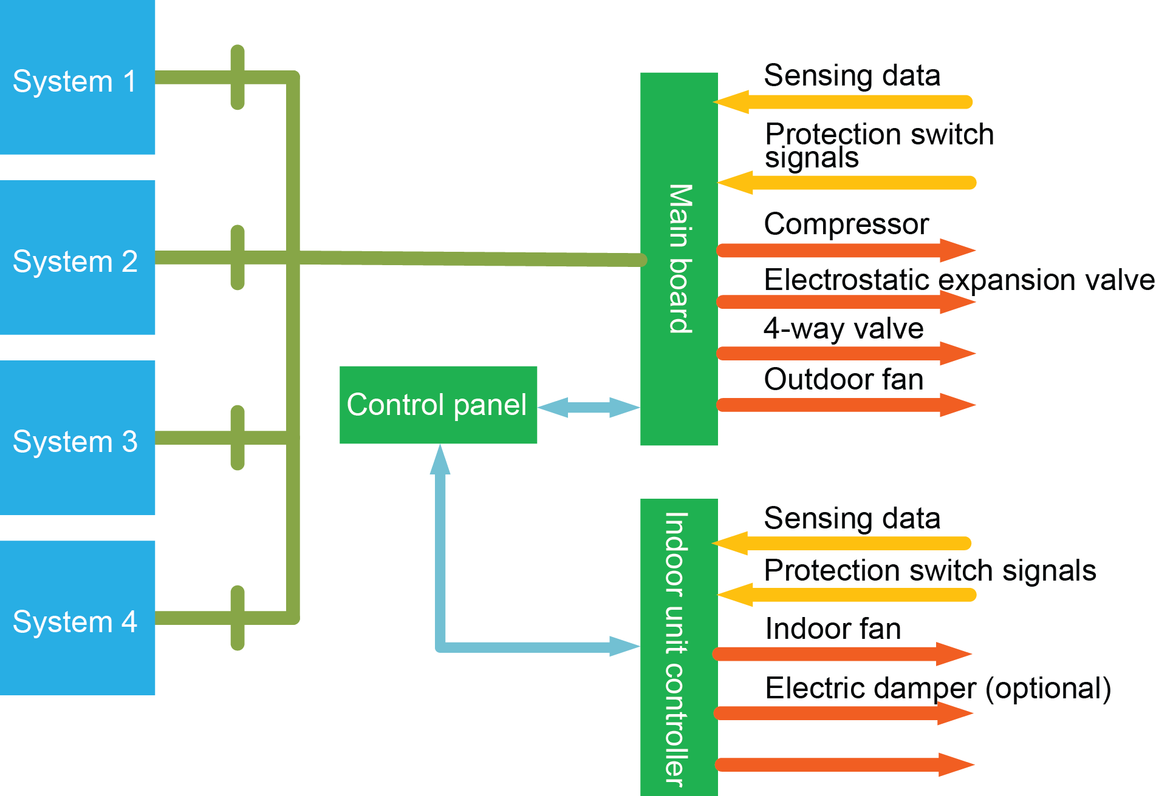
(2) Explanation to the Control Principle
Operation of the rooftop packaged unit is achieved through the microcomputer controller and DCC controller. The control panel can display and configure each parameter.
The compressor and condenser both are under control of the microcomputer controller, which can not only receive real time data from sensors and signals of switches but also directly control the electrostatic expansion valve, the compressor, 4-way valve, and the outdoor fan. The multi-system unit is entirely controlled by the microcomputer controller.
The DDC controller is used to receive real-time data of the air handling unit and singles of switches and directly control the indoor fan, electric damper and the auxiliary electric heater.

1.2 Control Flowchart
- Cooling
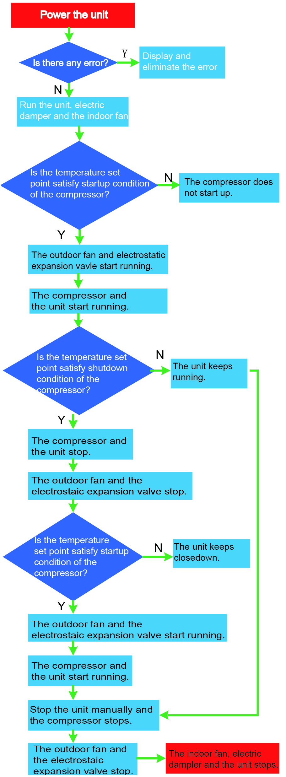
When the unit is powered on, firstly check if there is any error. If so, eliminate it. If elimination fails, do further check and troubleshooting. The unit is not allowed to be restarted until there is no any error.
When the unit is turned on, the electric damper will turn to the opening angle set point and then the indoor fan will start. Then, the system will detect if the indoor temperature satisfies startup conditions of the compressor. If not, the compressor does not run; if so, the outdoor fan and electrostatic expansion valve will start firstly, then the compressor and then the unit goes into operation.
During operation, the system will detect if the indoor temperature will meet standby conditions. If not, the unit will keep running. If so, the unit will go into the standby status, and then the outdoor fan and electrostatic expansion valve will stop. In this case, the system will continue to detect the indoor temperature.
When it is detected that the indoor temperature does not meet startup conditions, the unit keeps the standby status. When the indoor temperature again meets startup conditions, the outdoor fan and electrostatic expansion valve will start firstly, then the compressor and then the unit goes into operation.
When the unit is turned off manually, the compressor will stop firstly, then the outdoor fan and electrostatic expansion valve, and then the indoor fan and the electric damper.

- Heating
Introduction to Air Supplying Principle
When the unit is powered on, firstly check if there is any error. If so, eliminate it. If elimination fails, do further check and troubleshooting. The unit is allowed to be restarted until there is no any error.
When the unit is turned on, the electric damper will turn to the opening angle set point and then the indoor fan will start.
When the unit is turned off, the indoor fan will stop firstly and then is the electric damper.
- Air Supplying
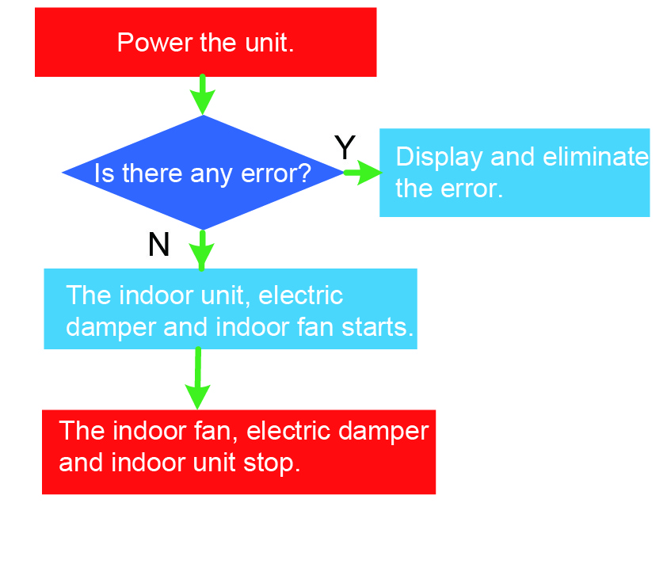
Introduction to Air Supplying Principle
When the unit is powered on, firstly check if there is any error. If so, eliminate it. If elimination fails, do further check and troubleshooting. The unit is allowed to be restarted until there is no any error.
When the unit is turned on, the electric damper will turn to the opening angle set point and then the indoor fan will start.
When the unit is turned off, the indoor fan will stop firstly and then is the electric damper.

2 Main Control Logic

2.1 Control to the Indoor Fan
- Cooling
When the unit is turned on, the electric damper will go to the target opening angle and the indoor fan will start and keep running, unless any error rises.
When the unit is turned off, the compressor will stop and stop of the indoor fan will be delayed.
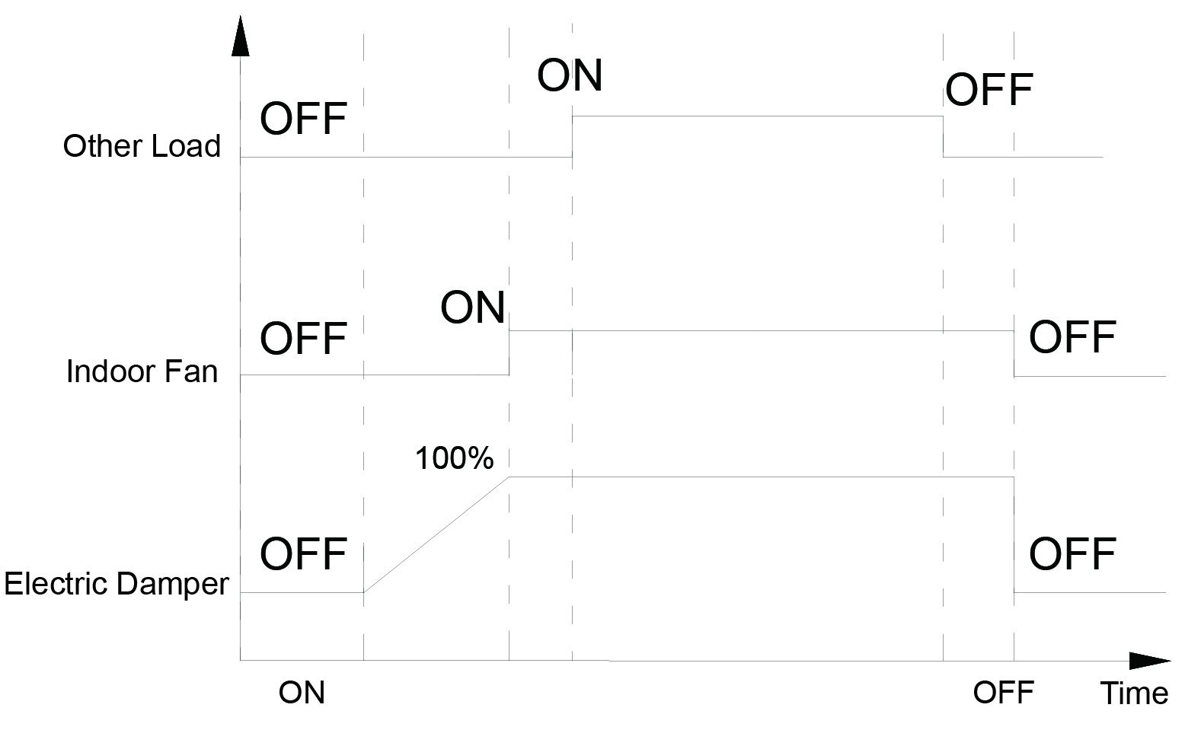
- Heating
When the unit is turned on, the electric damper will go to the target opening angle and the indoor fan will start.
When the unit satisfies defrosting start conditions, the electric damper will turn to the defrosting opening angle and the indoor fan will stop.
When the unit satisfies defrosting end conditions, the electric damper will turn to the target opening angle and the indoor fan starts.
When the unit is turned off, the compressor will stop and stop of the indoor fan will be delayed.
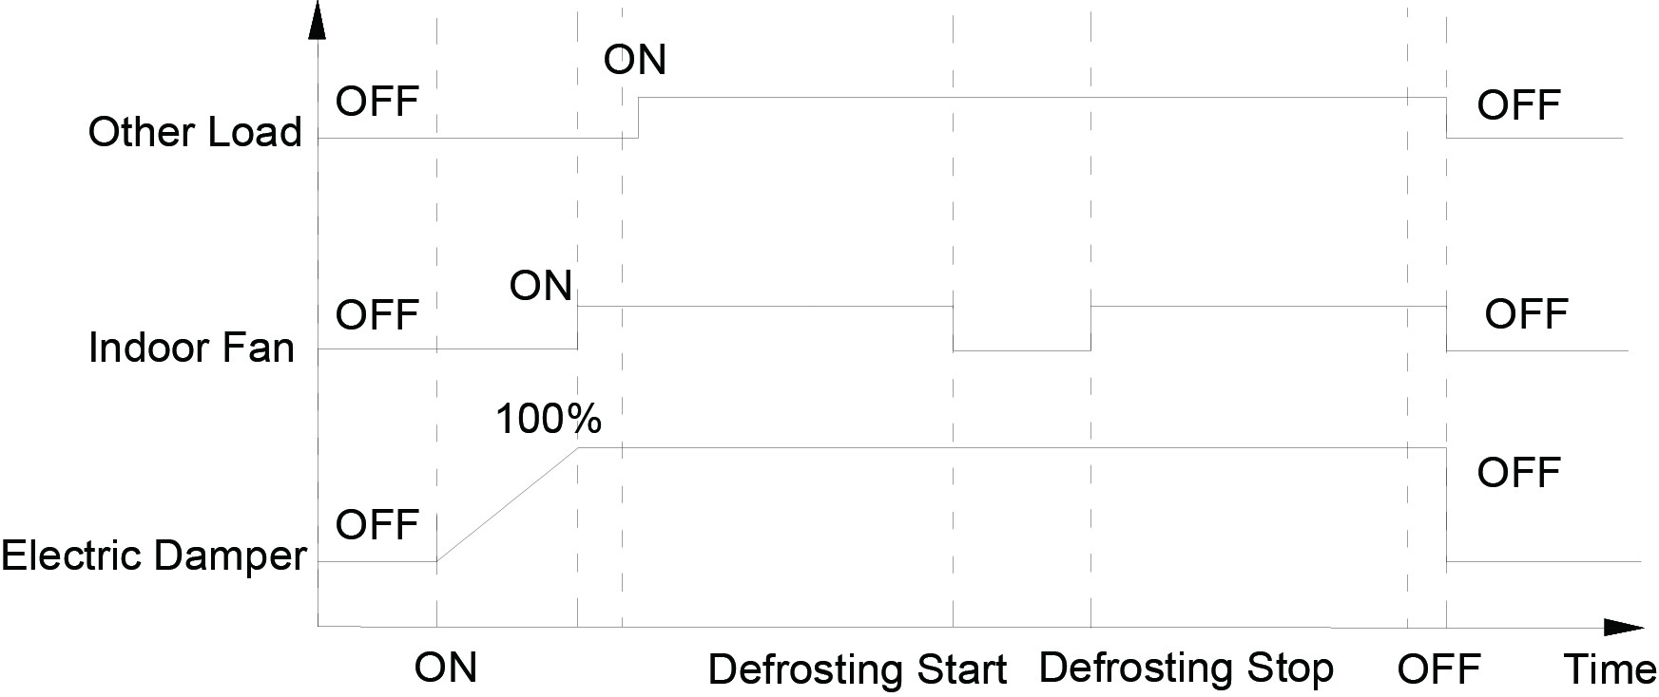
- Air Supplying
When the unit is turned on, the electric damper will go to the target opening angle and the indoor fan will start.
When the unit is turned off, the indoor fan also will stop.
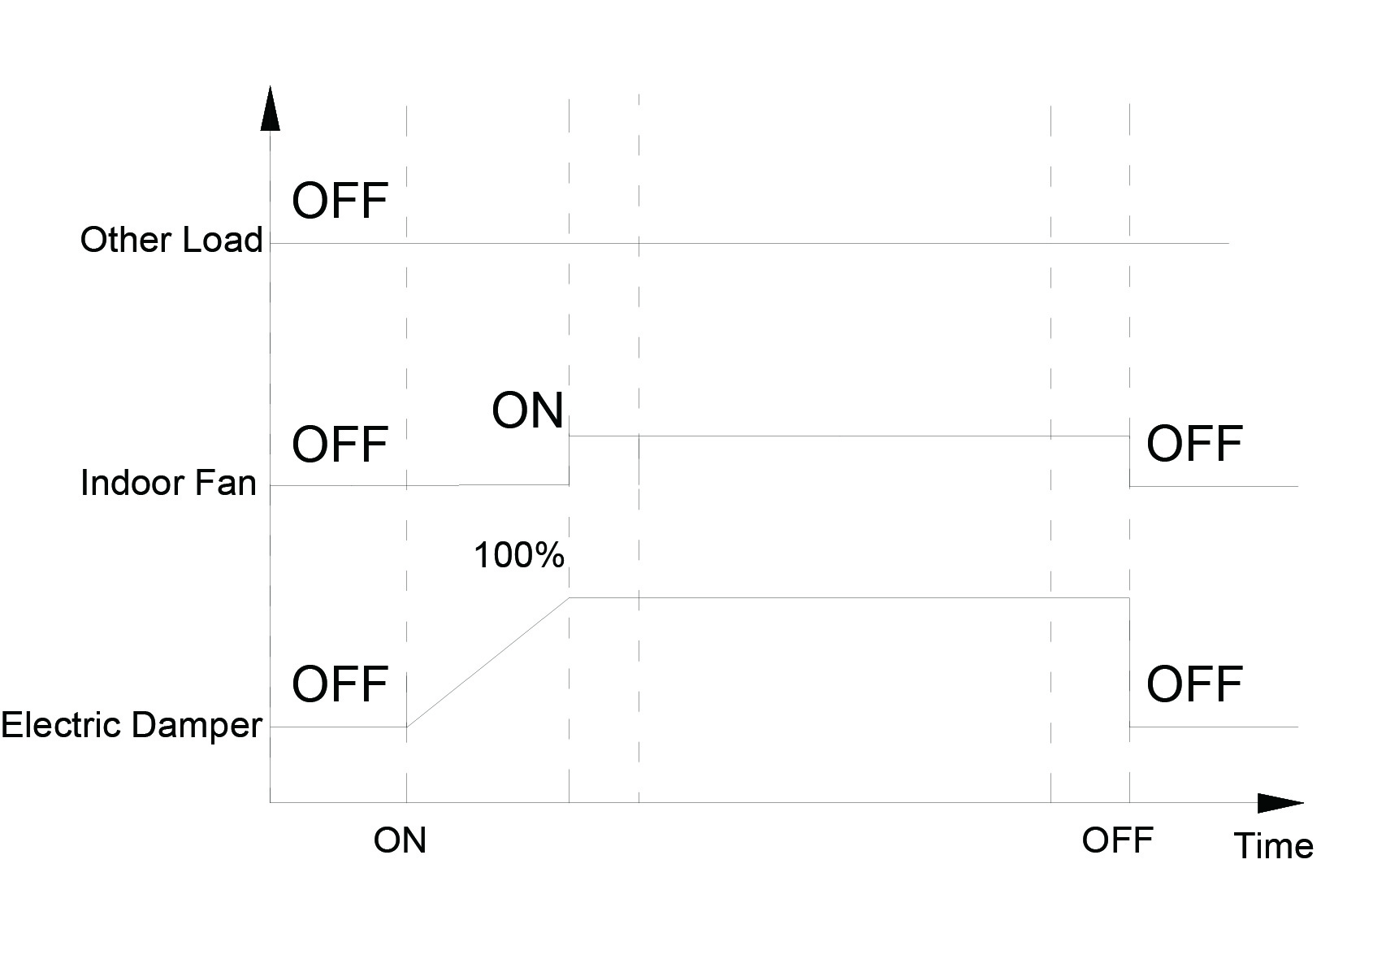

2.2 Control to Defrosting
Any system cannot operate separately during defrosting.
When it is detected that any system satisfies defrosting start conditions, other system also will be detected to see if they meet defrosting conditions or not. If so, they will come into defrosting at the same. If not, they will stop running.
When the unit goes into defrosting, the 4-way valve will reverse and the indoor and outdoor fans will stop.
When it is detected any system satisfies defrosting end conditions and other systems still are in defrosting, this system will stop defrosting and go into the standby status. That is, the compressor stops firstly, then the 4-way valve reverses and after that the outdoor fan stops.
When it is detected that the last system also satisfies defrosting end conditions, it stops defrosting, its 4-way valve reverses, and the indoor and outdoor fans starts. Other systems will act according to heating conditions.

3 Controller

3.1 Appearance and Functions
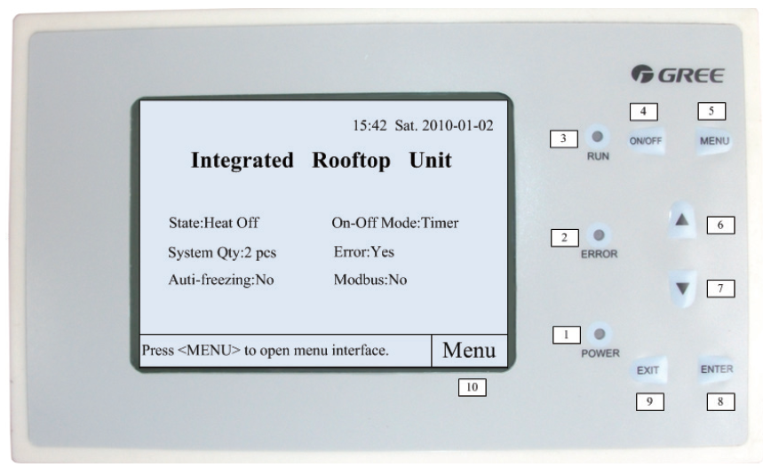
- Power indicating LED: it will light on when the controller is powered.
- Error indicating LED: it will blink when there is any error existing.
- Run indicating LED: it will light on when the controller is in operation.
- ON/OFF key: It is used to turn on or off the unit by pressing it for five seconds. Startup of the controller is passwords protected.
- MENU key: It can access to the menu page at any other page.
- ▲key: It can make the cursor move left or upward, and also can increase the setting value.
- ▼key: It can make the cursor move right or downwards and also can decrease the setting value.
- Enter key: At the homepage, it can access to the menu page. When selecting options, it indicates confirmation.
- Exit key: It will quit from the current option.
- Status bar: it simply indicates function of the function key.

3.2 DIP Switch
As shown in the figure below, DIP switches at the main board for the rooftop packaged unit locates at S4 and S2. “1” of S2 indicates fixed frequency (ON) of variable frequency (OFF) of the supply fan; “2” of S2 indicates existing (OFF) or non-existing (ON) of the hot water coils; “3” of S2 indicates structural type, packaged (ON) or split (OFF). S4 is used to distinguish model and system quantity. Each model requires an unique DIP setting.
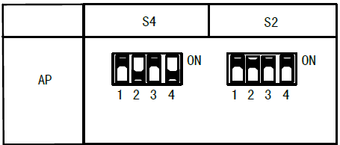

Unit Installation

1 Safety Precuations

1.1Precautions for Unloading
The rooftop packaged unit is quite large (W*H=2200*2510mm), attention should be paid during unloading so as to prevent the unit from being damaged. Two unloading methods stated below are for reference.
Method 1: when the outdoor unit faces the door of the container, bind the unloading board with the steel ropes and draw it outwards horizontally.
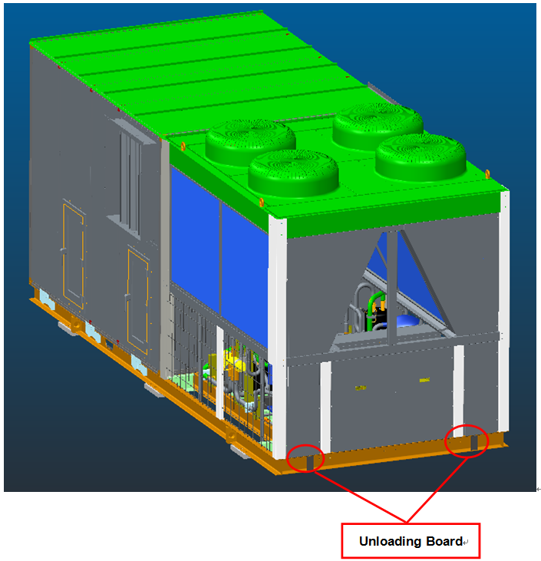
Method 2: when the indoor unit faces the door of the container, bind the unloading board with steel ropes and draw it out horizontally.
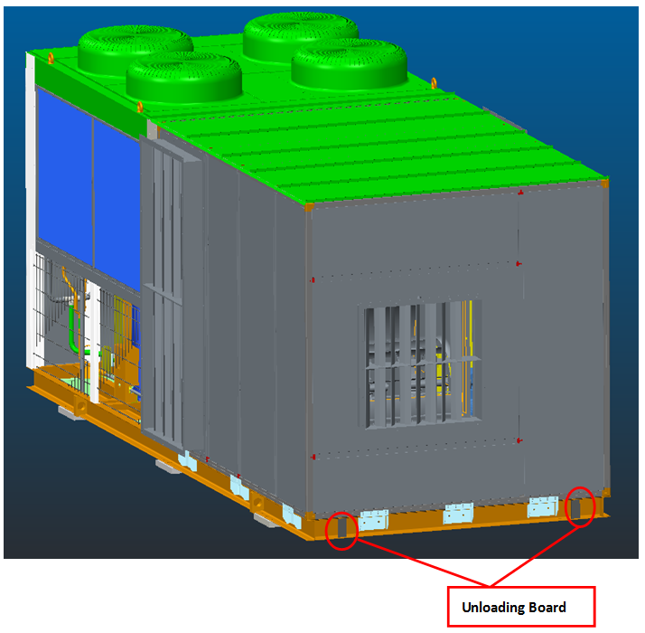

1.2Location of Air Grille/Diffusers
(1) The unit should be handled properly so as to avoid the unit from being damage or other possible dangers.
(2) Be sure the installation foundation is secure enough. When the unit is installed at the metal foundation, electric insulation should comply with relative technical standards.
(3) The installation location should be far away from inflammable and explosive substances so as to avoid explosion or fire hazard caused by their leakage.
(4) The unit should be installed where there is good ventilation. Care must be paid that discharge air and operation noise should produce no adverse effect to humans.
(5) When the unit is installed at the rooftop, pay attention to the wind direction. Strong wind should be avoided.
(6) There should no heat source, discharge outlet of other equipment around this unit, high-temp vapor, or flammable gas.
(7) There should be drain channels near the installation location for convenient drainage.
(8) This unit is not applicable to places with heavy magnetic field, high acidity and alkalinity and unstable voltage.
(9) When this unit is involved in the lightning system of the building, it should comply with GB50057-94-2000 Design Regulation of Lightning Protection of Buildings.

1.3Location of Air Grille/Diffusers
- WKR105NaA-M
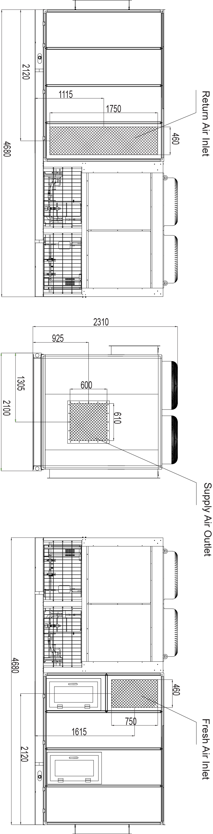
- WKR140NaA-M
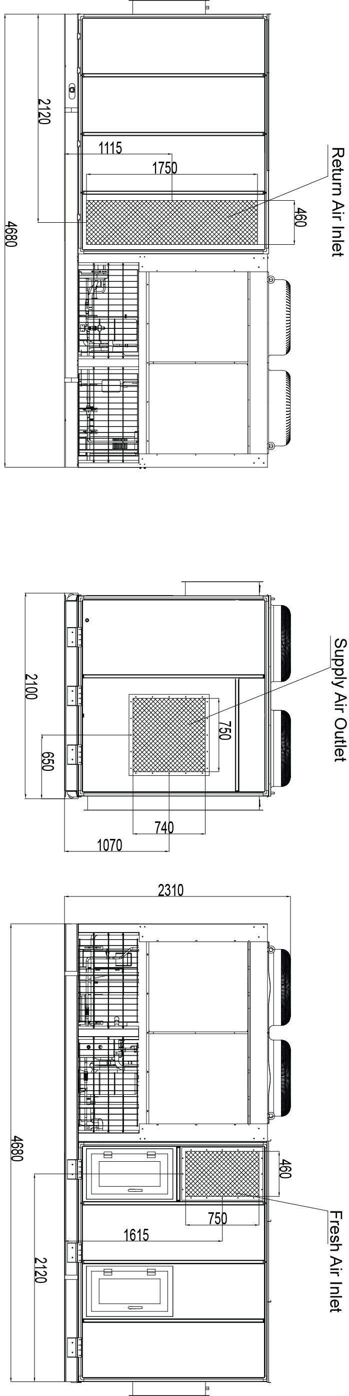
- WKR180NaA-M
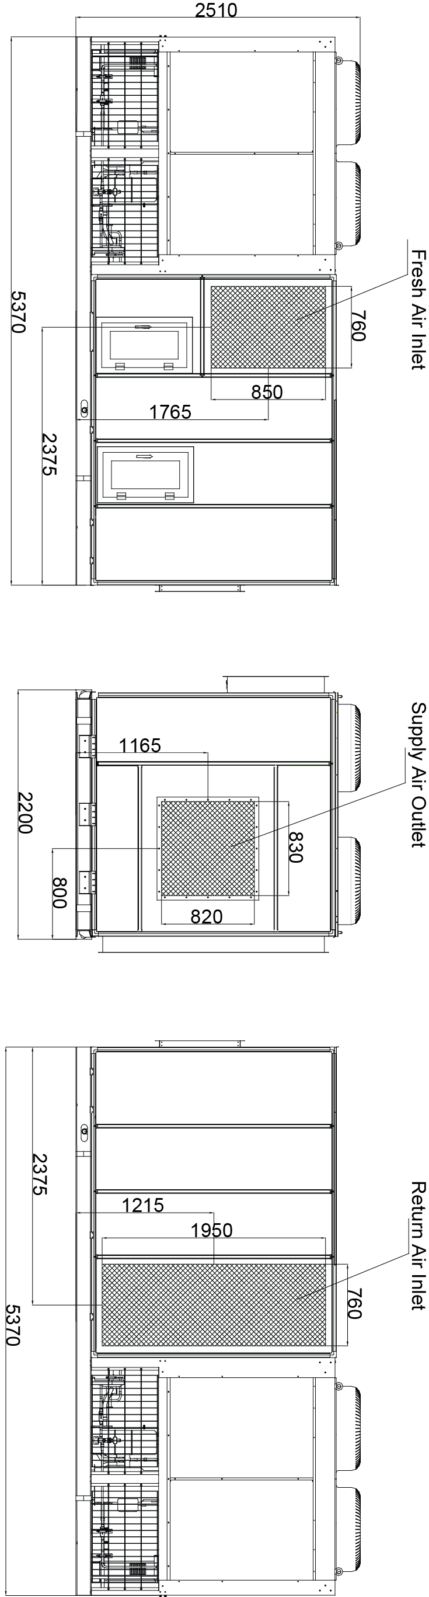
- WKR280NaA-M
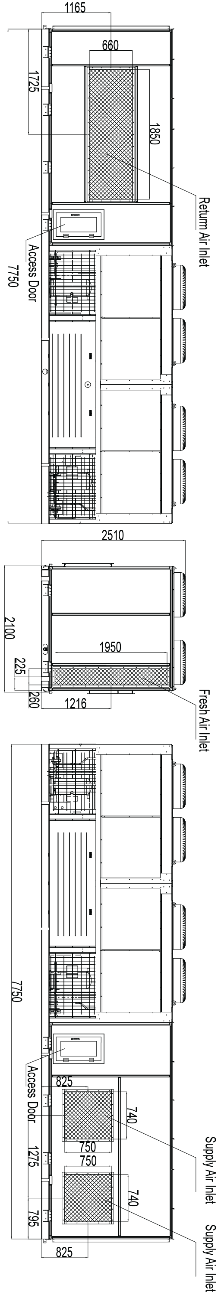
- WKR370NaA-M

1.4Diagrams of Installation Drawings
WKR105/NaA-M,WKR140/NaA-M,WKR180/NaA-M,WKR230/NaA-M, WKR280/NaA-M, WKR370/NaA-M
(Unit:mm)
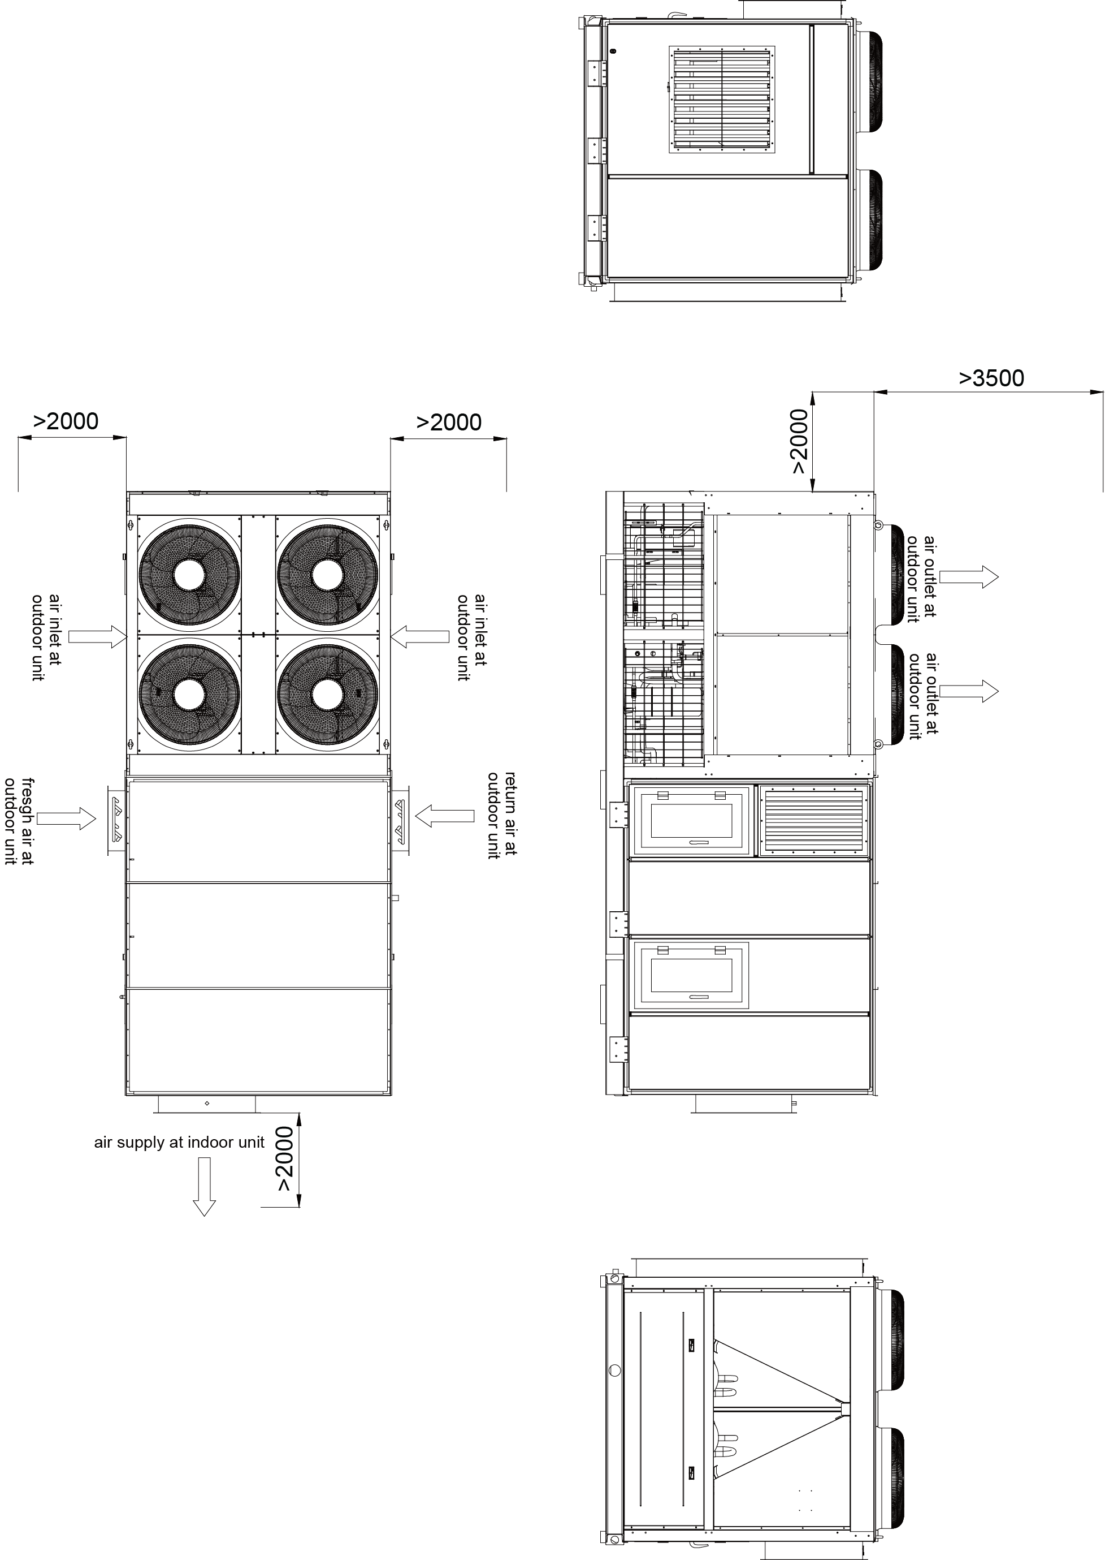

1.5 Requirements on Installation Base
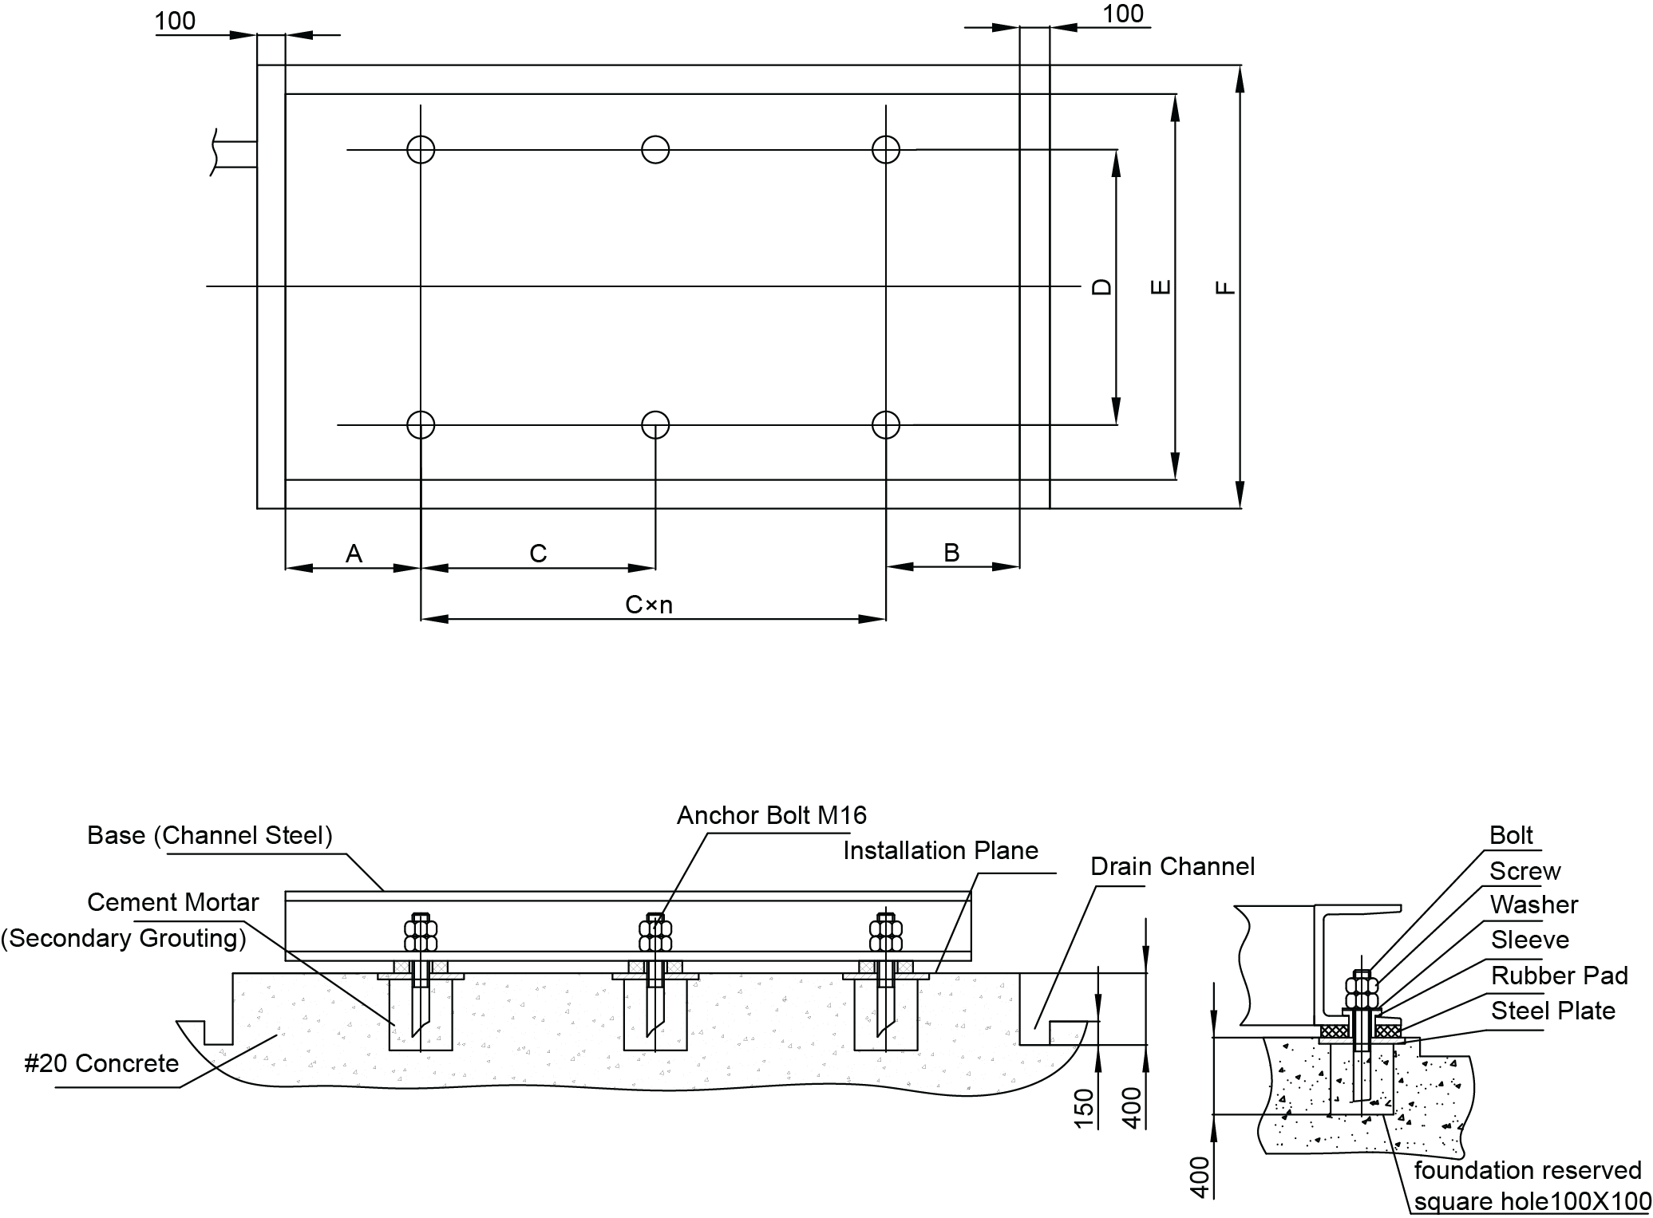
Figure 1 Diagram for the Installation Location (Unit: mm)
Models | A | B | C | C×n | D | E | F
WKR105/NaA-M | 650 | 700 | 1665 | 1665×2 | 2000 | 2050 | 2250
WKR140/NaA-M | 650 | 700 | 1665 | 1665×2 | 2000 | 2050 | 2250
WKR180/NaA-M | 795 | 830 | 1870 | 1870×2 | 2100 | 2150 | 2350
WKR230/NaA-M | 455 | 815 | 1620 | 1620×4 | 2000 | 2050 | 2250
WKR280/NaA-M | 455 | 815 | 1620 | 1620×4 | 2000 | 2050 | 2250
WKR370/NaA-M | 795 | 1305 | 1620 | 1620×5 | 2100 | 2150 | 2350
(1) The installation foundation should be designed according to the field conditions.
(2) The installation foundation should be made of concrete or steel structure and should support the operating weight of the unit. The surface of the installation foundation should be level.
(3) As shown in the figure above, the steel plate and rubber pad should be put on the foundation and then be grouted together with the anchor bolt. The installed anchor bolt should be 60mm higher than the installation plane.
(4) Proper installation, operation and maintenance space should be kept.
(5) The unit should be avoided to be affected by fire, inflammable substance, corrosive gas or waste gas. Space for ventilation should be kept. Besides, corrective measures should be taken to minimize noise and vibration.

1.6 Installation of the Condensate Pipe
The condensate pipe should be kept inclined so as to drain condensate. Connection of the condensate pipe should be insulated to prevent dewing. Beside, water seal is required, as shown in the figure below. Height of the water seal depends on pressure inside the condensate pipe.
When the condensate pipe is under negative pressure, A=B ≥ P/10+20(mm)
When the condensate pipe is under positive pressure, A ≥ 30mm, B ≥ P/10+20(mm)
P indicates absolute pressure inside the unit, (Unit: Pa)
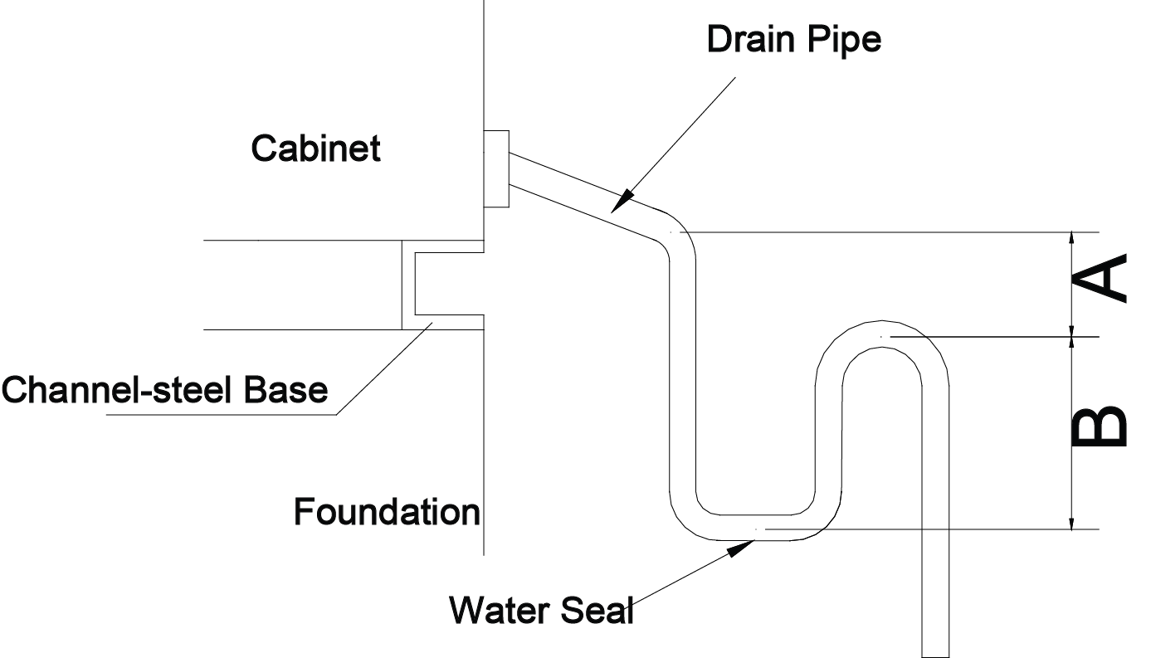

1.7 Installation of the Indoor Temperature Sensor
Installation of the indoor temperature sensor should guarantee that measurement is correct and it will not be damaged probably.
- Installation should be performed by the qualified technician.
- Installation location should:
- cover areas with average temperature;
- facilitate operation;
- involves with most of human activities;
- be far away from heat sources, radiators, doors, and windows. Installation height should be kept about 1.4m and keep a distance of 0.8m with door and windows.
- The square junction box is required
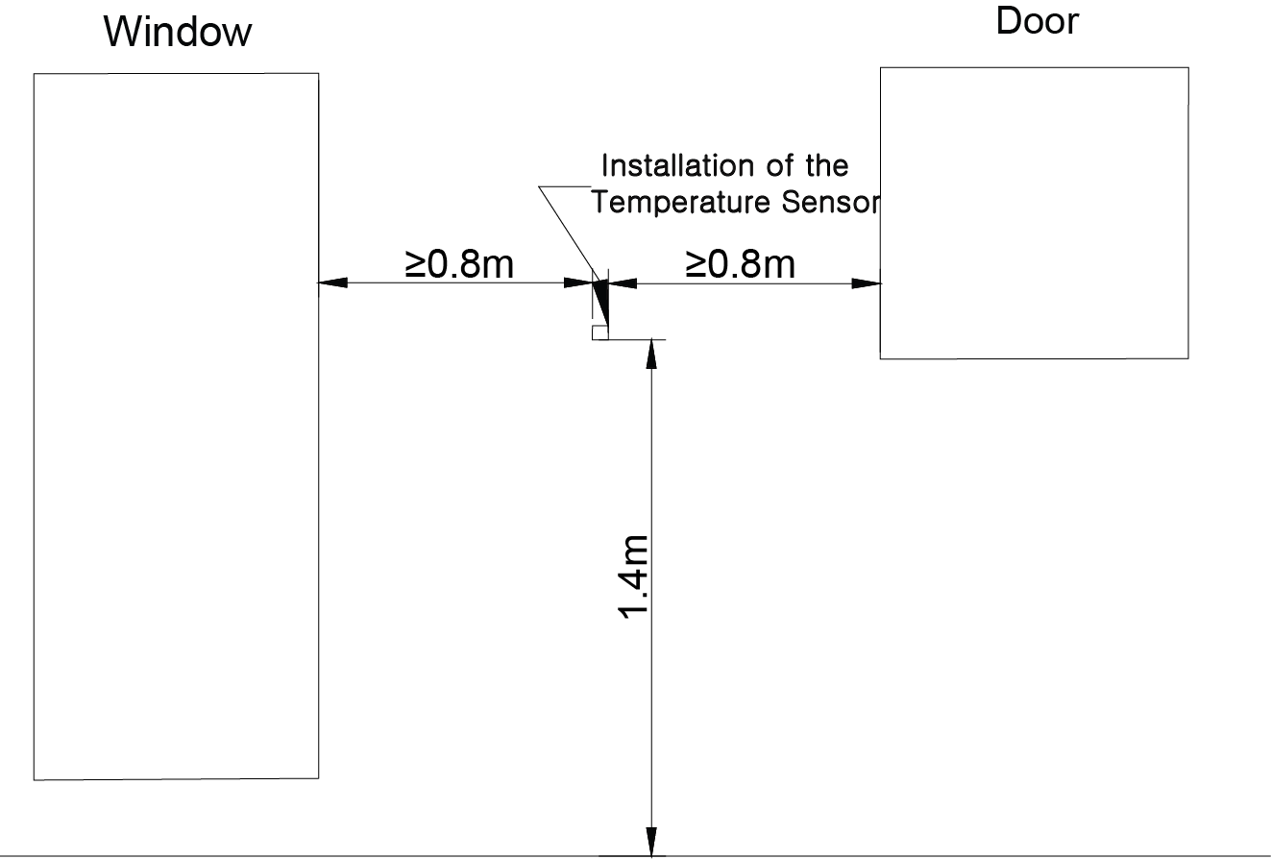

1.8Installation of the Control Panel
- The control panel should be embedded in the dry and enclosed space.
- Maintenance should be performed by qualified technician.
Case 1 Control Panel Embedded in the Wall
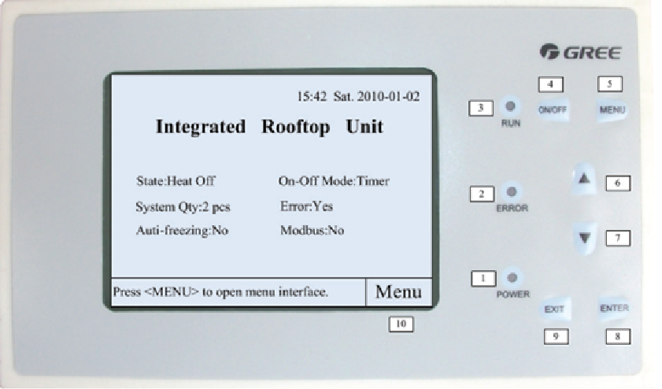
Case 2. Control Panel inside the Electric Control Cabinet

2 Required Tools for Instalation
Name | Image | Usage
Inner Hexagon Spanner | 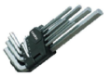 | To fix the taper sleeve of the belt pulley
Glue Gun | 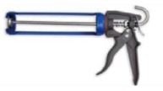 | To seal joints
Chain Block | 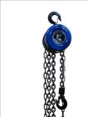 | To move heavy objects
Pipe Wrench |  | To install tubes
Percussion Drill | 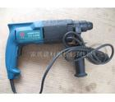 | To install brackets
Torque Spanner | 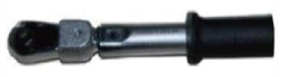 | To fix ducts
Hand Electric Drill | 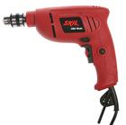 | To install ducts
Steel Band Tape | 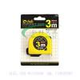 | To determine length
Level Bar |  | To determine distance
Centering Apparatus | 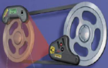 | To adjust parallelism of the belt pulley
Wind Velocity Indicator | 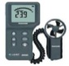 | To determine wind velocity

3 Fabrication and Installation of Ducts

3.1 Precautions for Connection between Ducts and Air Grills/Diffusers
1. The air grille/diffuser should be connected with the canvas flexible joint, which can reduce vibration and noise.
2. It is suggested to install the plenum between the duct and the air grille/diffuser so as to reduce dynamic pressure, increase static pressure and stabilize air flow.
3. Rigid connection can be between the duct and the plenum.
4. Length of the canvas flexible joint is recommended to be 150mm~300mm and diameter of two ends should be the same as that of the duct.
See the figure below for how to install the air grille/diffuser.
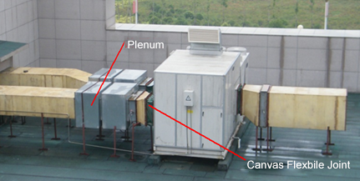

3.2 Fabrication of Metal Ducts
- Fabrication Flowchart
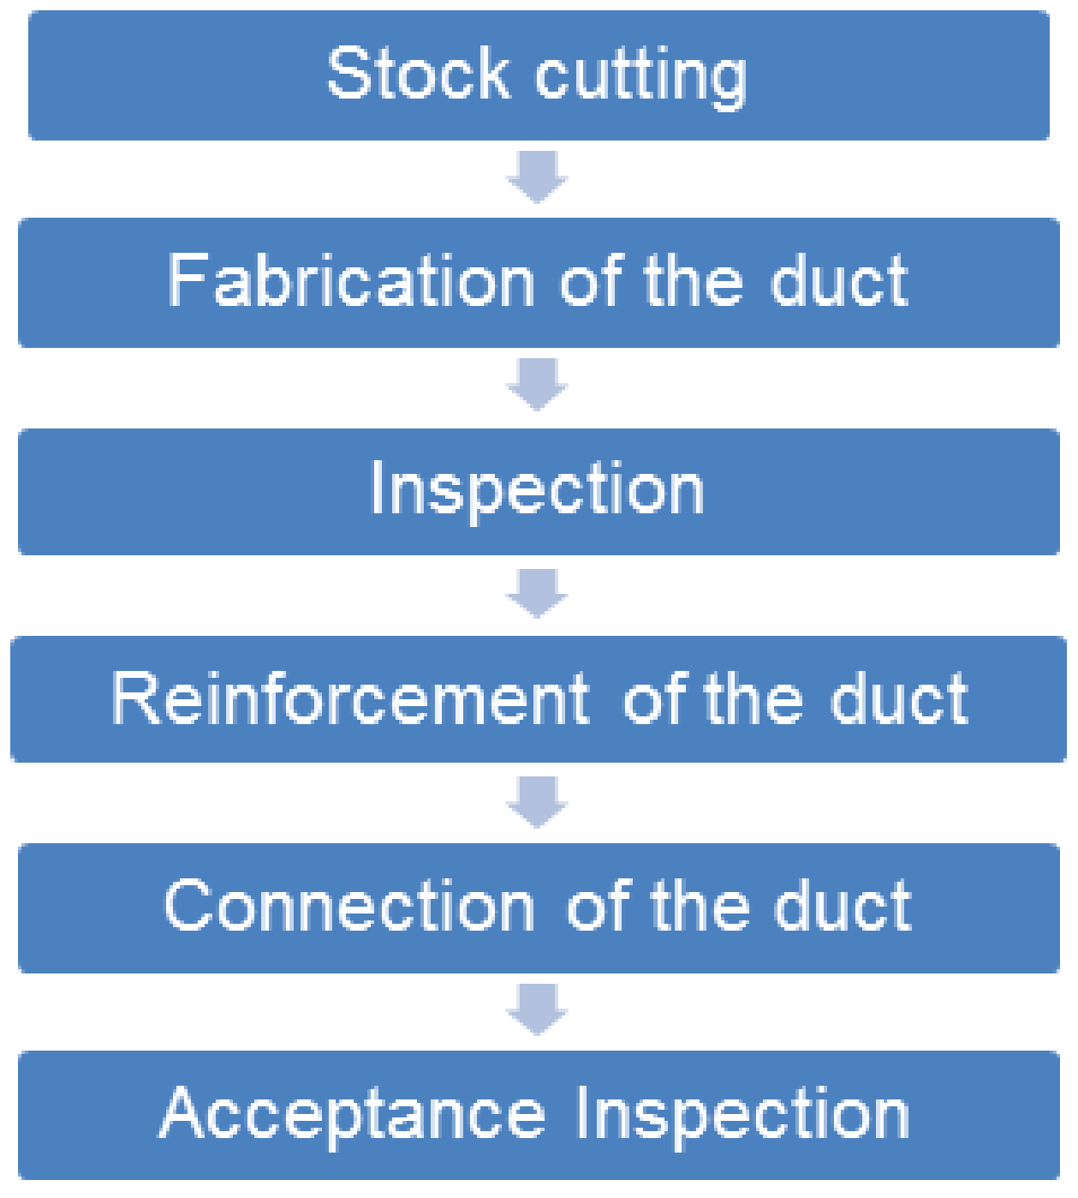
- Stock Cutting
- Figure out the processing drawing based on the design drawing of the duct.
- Make sure what is the unfolded duct drawing for stock cutting.
- Do stock cutting by the cutting machine. Note: before stock cutting, make clear how thick the material is, what type is the joint of the sheet material and what type is the duct and pay attention to the allowance.
- Start cutting when all gets ready.
- Tools
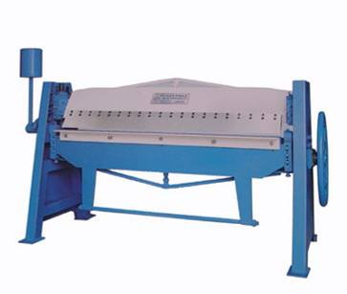
Edging Machine
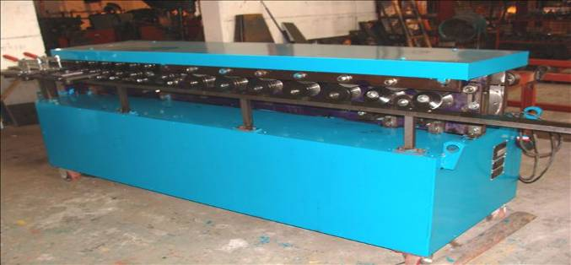
Flange Machine
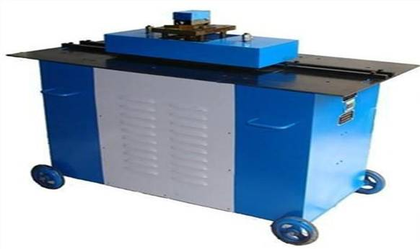
Nip Machine
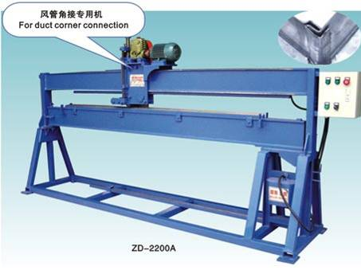
Beading Machine
- Fabrication of the Duct
There are generally three methods for connection of metal sheets, interlocking, riveting and welding. Among them, interlocking is the most common way.
Limits for Interlocking and Welding of the Metal Ducts
Thickness (mm) | Material
 | Steel Sheet | Stainless Steel Sheet | Aluminum Sheet
δ≤1.0 | Interlocking | Interlocking | Interlocking
1.0≤δ≤1.2 |  | Welding  (argon or electric arc)
1.2≤δ≤1.5 | Welding  (electric arc) |  | Welding  (argon or electric arc)
δ＞1.5
When fabricating metal ducts, the single interlocking is applicable to the splicing joint of sheet materials, the vertical closed joint of the round duct, or connection of options which require no strict tightness requirement. The vertical interlocking is applicable to the ring-type joint at the end of the round duct; the corner or associated corner or button type interlocking is for four corners of the rectangular duct or other options. The associated corner interlocking is applicable to the rectangular duct, bends, three-way valves, and 4-way valve. The button-type interlocking is applicable to the corner joint of the rectangular duct and options.
The interlocking is generally pressed mechanically.
Single interlockin | Button type interlocking | Corner interlocking | Associated corner interlocking | Vertcial interlocking
Interlocking Type of the Duct
- Fabrication of Flanges of Metal Sheets
1) The welding joint of the flange should be favorable and complete and with no any slag entrapment and holes.
2) Flanges with the same size should be interchangeable.
3) There should be screw holes at four corners of the rectangular duct and the hole size should be 1.5mm larger than the screw bolt.
Size of the Flange Bolt of the Metal Rectangular Duct
Longer Side of the Duct | Screw Bolt | Longer Side of the Duct | Screw Bolt
b≤630 | M6 | 1500＜b≤2500 | M8
630＜b≤1500 | M8 | 2500＜b≤4000 | M10
- Inspection on the Metal Duct
1) Allowance for the outer diameter and side of the duct should be negative.
2) The allowance is -1mm when the duct is or less than 300mm long, and -2mm when it is larger than 300mm long.
- Reinforcement of the Metal Duct
1) When the diameter of the round duct is or larger than 800mm, and the total length is larger than 1250mm or the total area is larger than 4m², then it should be reinforced.
2) When the side of the rectangular duct is longer than 360mm, the side of the insulation is longer than 800mm, duct length is larger than 1200mm, or singe-side area of the low-pressure/high-pressure duct is larger than 1.2m² /1.0 m², it should be reinforced.
3) The metal duct can be reinforced by ribs, angle steel, flat steel and inner supporters.
- Connection Requirements on the Metal Duct
1) The metal duct is usually connected with the flange.
2) Thickness of the flange gasket is better to be kept about 3.5mm.
3) When the delivered air is lower than 70℃, rubber plate, closed-cell sponge rubber plate, seal tape or other closed-cell elastic material can be used.
4) The flange gasket for the duct of the clean air conditioning should be made of elastic materials, produce no dust and not aging.
5) The sealing gasket should be connected in the trapezoid or tenon mode and will not protrude inside the duct or come off.
- Insulation of the Metal Duct
Insulation Location | Closed-cell Foamed Plastic |  | Block of Glass Wool
 | Class I District | ClassⅡDistrict | Class I District | ClassⅡDistrict
Non air conditioned area | ＞20mm | ＞20mm | ＞30mm | ＞40mm
Air conditioned area | ＞20mm | ＞20mm | ＞25mm | ＞30mm
Note: the low-temperature duct or duct in the hot and humid area should be insulated

3.3 Fabrication of Compound Ducts
(1) Stock Cutting
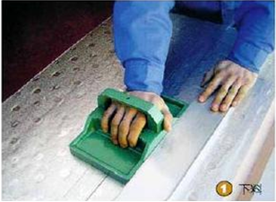
(2) Glue Applying
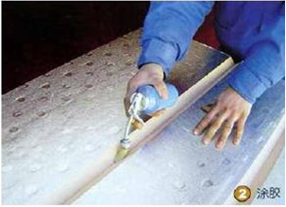
(3) Tube Connecting
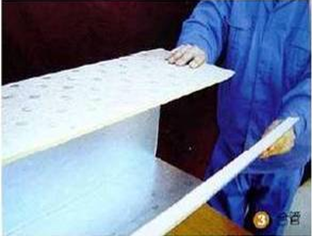
(4) Laminating
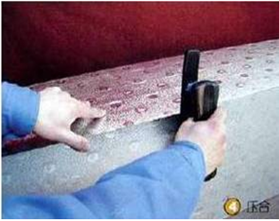
(5)Adhesive tape pasting
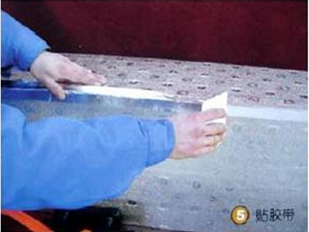
⑹ Flange installing
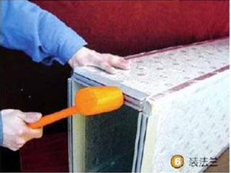
⑺Sealing
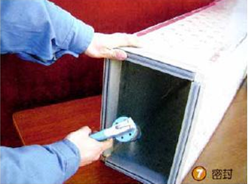

3.4 Requirements on Fabrication of Ducts
  - The duct should be made of non-inflammable materials, which also should be given priority for insulation materials.
  - Type, size, thickness and properties of both the metal or non-metal ducts should comply with the current design and product standards.
  - Main body, frame, fixing material and sealing material of the fire-proof duct should be non-inflammable and its fire-proof class should comply with the relative design regulations.
  - The coating material of the compound duct should be non-inflammable and the inner insulation material should be also non-inflammable or B1flame retardant. Smoke density cannot be larger than 10 and produce no adverse effect to human body.
  - Length radio of two neighboring sides of the rectangular duct should be kept less than 6:1.
  - The reducing duct should varies gradually but not dramatically.
Concentric Increasing or Decreasing | Eccentric Increasing or Decreasing

3.5 Fabrication of Plenums
The plenum is required to reduce dynamic pressure, increase static pressure, and stabilize the air flow for the supply air system. Besides, it can optimize the supply air flow and minimize operation noise.
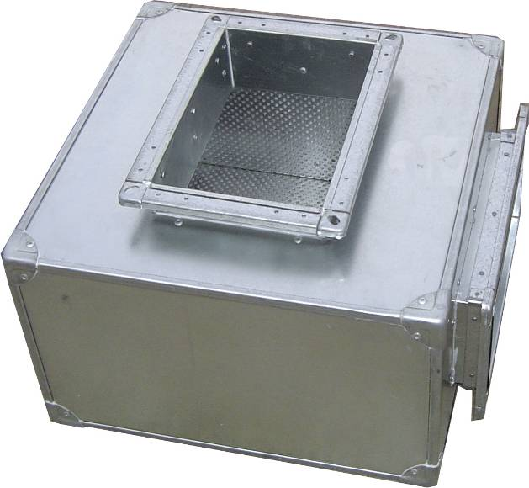
Sectional area of the plenum= air flow ÷ air velocity inside the cabinet (generally about 2.5m/s)
Generally both the length and height of the plenum should be 400mm larger than the width, and thickness of the cabinet would be better to be larger than 600mm.
Addition of keel, sound-insulation cotton, glass cloth and perforated plate inside the plenum can enhance the sound insulation effect.

3.6 Installation of the Duct System

3.6.1 Installation Flowchart
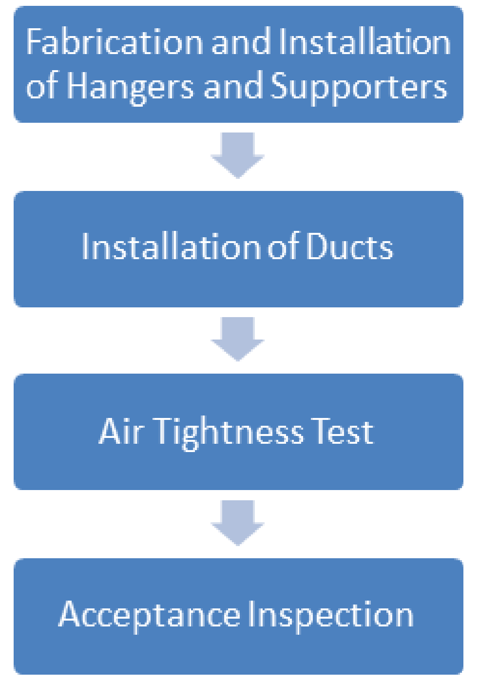

3.6.2 Fabrication and Installation of Hangers and Supporters
Requirements on Fabrication of Hangers and Supporters
1) Firstly correct torsion and bend of the section steel.
2) Store cutting of hangers and supporters should be done mechanically. When gas cutting is used, further grinding is required.
3) Holes should be made by the bench drill or hand-held electric drill but no by electro-gas welding or chambering
4) Welding of hangers and supports should be clean and tidy and make sure welding is enough, secure and with no missing, inadequacy, crack, or internal undercut etc.
5) The hanger rod should be straight and screw thread should be intact and smooth.
6) After installation, they should be painted except those embedded underground.
7) For hangers for the stainless steel and aluminum ducts, anti-corrosion measures should be taken for anchor ears as per design requirements so as to prevent electric and electrochemical corrosion.
Table 1: Minimal Size of the Hangers for the Horizontal Metal Rectangular Duct (mm)
Side Length | Diameter of the Hanger Rod | Cross Arm
 |  | Angle Steel | Channel Steel
b≤400 | Φ8 | ∟25×3 | ［40×20×1.5
400＜b≤1250 | Φ8 | ∟30×3 | ［40×40×2.0
1250＜b≤2000 | Φ10 | ∟40×4 | ［40×40×2.5  ［60×40×2.0
2000＜b≤2500 | Φ10 | ∟50×5 | --
b＞2500 | As designed

Table 2: Minimal Size of the Hanger of the Horizontal Metal Round Duct (mm)
Diameter | Diameter of the Hanger Rod | Anchor Ear |  | Cross Arm  (Angle Steel)
 |  | Steel Wire | Flat Steel
D≤250 | Φ8 | Φ2.8 | ―25×0.75 | --
250＜D≤450 | Φ8 | 2×Φ2.or Φ5
450＜D≤630 | Φ8 | 2×Φ3.6
630＜D≤900 | Φ8 | -- | ―25×1.0 | --
900＜D≤1250 | Φ10 | --
1250＜D≤1600 | 2×Φ10 | -- | 2×―25×1.5 | ∟40×4
1600＜D≤2000 | 2×Φ10 | -- | 2×―25×2.0
D＞2000 | As designed

Table 3: Sizes of the Non-metal Duct for Installation of the Horizontal Cross Arm (mm)
Duct Type | ∟25×3  ［40×20×1.5 | ∟30×3  ［40×20×1.5 | ∟40×4  ［40×20×1.5
PUR Aluminum Foil Compound Duct | b≤630 | 630＜b≤1250 | b＞1250
PF Aluminum Foil Compound Duct | b≤630 | 630＜b≤1250 | b＞1250

Table 4: Diameter for Hangers of the Non-metal Duct (mm)
Duct Type | Diameter of the Hanger Rod
 | Φ6 | Φ8
PUR Aluminum Foil Compound Duct | b≤1250 | 1250＜b≤2000
PF Aluminum Foil Compound Duct | b≤800 | 800＜b≤2000

Table 5: Maximal Spacing for Hangers of the Metal Duct (mm)
Side Length of Diameter | Rectangular Duct | Round Duct
 |  | Vertical Interlocking | Helical Interlocking
≤400 | 4000 | 4000 | 5000
＞400 | 3000 | 3000 | 3750

Table 6: Maximal Spacing for Hangers of the Non-metal Duct (mm)
Duct Type | Side Length
 | ≤400 | ≤1000 | ≤1600 | ≤2000
 | Maximal Spacing between Hangers/Supporters
PUR Aluminum Foil Compound Duct | ≤4000 | ≤3000
PF Aluminum Foil Compound Duct | ≤2000 |  | ≤1500 | ≤1000

3.6.3 Regulations on Installation of Hangers and Supporters
1) Location for the embedded part of the hangers/supporters should be correct, secure and reliable. Rust and oil grease on it should be cleared. Besides, anti-corrosion measures should be taken but not by painting.
2) The hangers/supporters should not be placed at the air inlet/outlet, valves, access door, or operating part of the self-controlled mechanism. They should be kept a distance of no less than 200mm with the air inlet/outlet or plug-in tube.
3) The anchor bolt should be used at the concrete member with the strength class higher than C15. Distance from the bolt to the edge of the concrete member should not be less than 8 times diameter of the bolt, and 10 times when bolts combination is used.
4) The horizontal duct against the wall or post would be better to use cantilever supporters and sprag type supporters. For those not against the wall or post, brackets should be used. For the ducts with the diameter or longer side less than 400mm, the belt-type hangers should be used.
5) The vertical duct against the wall or post should use cantilever supporters and sprag type supporters. For those not against the wall or post but through the floor, anchor ears should be used. For vertical ducts outdoor or on the ground should be fixed with the head-frame or guyrope.
6) After installation, be sure forces applied at the hangers are even and produces no deformation. Deflection of the cross arm should be less than 9mm.
7) For the system with the horizontal length of the duct longer than 20m, at least one anti-swing fixing supporter is required.
8) The cross arm should be placed outside the insulation of the duct but will not product any damage.
9) Hangers should be placed outside the duct insulation of the duct and direct contact should be avoided but via thermo-insulated and anti-corrosion materials whose thickness should be the same with the duct insulation so as to prevent generation of cold bridge.

3.6.4 Regulations on Installation of Hangers/Supporters of the Metal Duct
1) Anti-corrosion measures should be taken for the contact site of the stainless steel and aluminum duct with the carbon steel supporters.
2) Clearance between the vertical side and the hanger rod should be kept no more than 150mm, and distance from the hanger rod and the duct end should be no more than 1000mm.
3) A supporter is required every 500mm for the horizontal duct and when distance of the branch and main duct is 1200mm.
4) When the duct is installed vertically, spacing between supporters should not be larger than 4000mm. For the single duct no less than 1000mm, at least two fixing points are required.
5) For connection between the damper with side length or diameter larger than 200mm and the non-metal duct, single hanger/supporter is required.
6) For vertical PUR and PF aluminum compound ducts, spacing between supporters should not be larger than 2400mm. At least two supporters are required for each vertical duct.

3.6.5 Installation of the Duct
1) When the duct is installed at the surface, levelness every meter should not be larger than 3mm, and total allowance should be kept within 20mm; Verticality should not be larger than 2mm and the total allowance should be kept within 20mm.
2) For concealed duct, location should be correct and there is no obvious allowance.
3) The branch duct should be installed before the main.
4) When the duct goes through the totally enclosed fire-proof, explosion-proof wall or floor, protection tube should be embedded ahead. Thickness of the steel plate should be no less than 1.6mm. Gas between the duct and the protection tube should be stuffed with non-inflammable and harmless flexible materials.
5) Joints for the compound duct should be secure, with no holes and cracks.

3.6.6 Airtight Test to the Ducts
Light leak test: it aims to test the tightness of the duct by means of penetrating power of lights going through the hole.
1) Light source: safety light source or hand-held illuminating lamp no less than 10W with the protective cover. The test targets mainly are main and branch ducts.
2) Sampling quantity: sampling test is used for the low-pressure system. The sampling ratio is 5% and no less than 1 system. The acceptance standards are there are less than two light leaks every 10m joint and less than 16 light leaks on average for 100m joint.
3) Leak test: the sampling test should be 100% passed. If the test fails, the sampling quantity should be doubled until all is passed.

3.6.7 Air Grille and Diffusers
(1) Dual-layer Grill
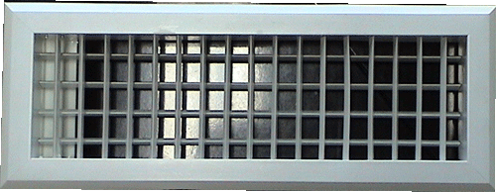
(2) Square Diffuser
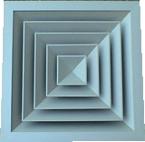
(3) Return Air Grille
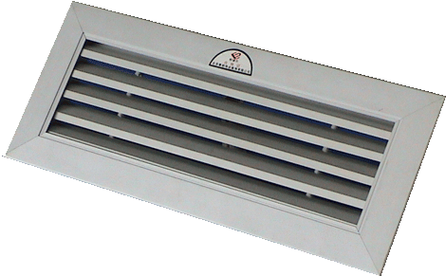

Test Opration & Troubleshooting & Maintenance

1 Commissioning

1.1 Checkup before Commissioning

1.1.1 Installation of the Unit
Is the installation foundation satisfactory?
Is the unit fixed effectively?
Does the installation location meet requirements on maintenance and ventilation space?

1.1.2 Electric
Is the power distribution cabinet equipped?
Is the air switch inside the power distribution cabinet satisfactory?
Is the power line selected and arranged properly?
Is the wiring reliable and complete? Are phase sequences correct?

1.1.3 Duct
Is the flexible joint used for the duct?
Are sealing and insulation measures taken to the duct?
Does installation of the duct comply with relative standards?

1.1.4 Drainage
Is drain pipe prepared at the discharge outlet of the evaporator? Is the return trap for the drain pipe?

1.2 Commissioning
Tools required: thermoanemomete, screw drivers (both straight and cross), test pencil, adjustable resistance, adjustable wrench, pressure guage.

1.2.1Removal of Impurity inside the Duct
Before electrifying the unit, open the manual supply air damper and make sure all valves are open. After electrifying the unit, observe and see: is operation sequence of the damper and fan is correct? Is there any unusual noise? When the unit has run for about 30min or there is no any impurity out from the air grille/diffuser, clean impurity inside the duct. Meanwhile, determine the air velocity at the supply air outlet and air grille/diffuser with the thermoanemomete.

1.2.2 Cooling during Commissioning
After commissioning at the supply air mode is finished, start the cooling mode. Then, observe and see: is operation sequence of the damper and other elements correct? Is there any usual noise from the compressor and fan? When all systems of the unit come to stable operation, record each temperature, and determine supply air temperature at the supply air outlet with the thermoanemomete.
Discharge temperature ℃ | Condenser Vapor Line Temp℃ | Condenser Liquid Line Temp℃ | Evaporator Liquid Line Temp℃ | Difference of Return and Supply Air Temp ℃
70～95 | 70 | 35～50 | 8～15 | 10～20
High Pressure kPa |  | Low Pressure kPa |  | Evaporator Vapor Line Temp ℃
2500～3700  Relative to outdoor temperature |  | 800～1200  Relative to indoor temperature |  | 10～17
Meanwhile, observe oil level through the sight glass. In normal condition, oil lever should be 1/2 of the sight glass (the lower limit for the Copeland compressor is oil level at the bottom of the sight glass. Cleanliness of refrigeration oil also should be checked.

1.2.3 Heating during Commissioning
After commissioning at the cooling mode is finished, start the heating mode. Then, observe and see: is operation sequence of the damper and other elements correct? Is there any usual noise from the compressor and fan? When all systems of the unit come to stable operation, record each temperature, and determine supply air temperature at the supply air outlet with the thermoanemomete.
When the ambient temperature is higher than 25℃, some part of the outdoor finned heat exchanger should be closed up so as to lower the evaporating pressure.
Discharge temp℃ | Condenser vapor line temp ℃ | Condenser liquid line temp（℃） | Evaporator liquid line temp ℃ | Difference of Return and Supply Air Temp ℃
60～95 | 8～15 | 10～17 | 30～50 | 10～20
High Pressure kPa |  | Low Pressure kPa |  | Evaporator Vapor Line Temp ℃
2500～3500  Relative to outdoor temperature |  | 700～1200  Relative to indoor temperature |  | 55～70
Meanwhile, observe oil level through the sight glass. In normal condition, oil lever should be 1/2 of the sight glass (the lower limit for the Copeland compressor is oil level at the bottom of the sight glass.

2 Error List
Name | Control Logic | Possible Causes | Troubleshooting
Compressor high pressure protection | When it is detected that some high pressure switch is opened, the system will raise an alarm and the control panel will display this error. | - There is incondensable gas inside the system.  - During cooling, fins are too dirty or installation space is too small.  - During cooling, the fan breaks down or run reversely.  - Refrigerant is overcharged.  - Environment temperature is too high for cooling.  - Indoor temperature is too high for heating.  - The high pressure protection works unusually.  - EXV works unusually.  - The check vale or the filter-drier is clogged.  - The indoor fan works unusually.  - The filter is clogged for heating.  - The air flow is too low for heating. | - Vacuum the system again and open all EXVs and solenoid valves.  - Clean it or correct the installation space.  - Repair the fan.  - Recharge as per the nameplate.  - Check for operation range which should comply with design requirements.  - Check for operation range which should comply with design requirements.  - Check it. If it is broken, replace it.  - Check for its wiring and moving parts. Are they jammed or damaged?  - Check for pressure drop before and after the check valve or the filter. If it is too large, replace the check valve or filter.  - Repair the indoor fan.  - Clean or replace the filter.  - Check for opening angle of the damper.
System freeze protection | When it is detected that liquid line temperature of the indoor fins is too low, the system will come into protection and the control panel will display this error. | - Temperature of the indoor unit is too low for cooling  - Environment temperature is low for cooling  - The filter is clogged. | - Check for operation range which should comply with design requirements.  - Check for operation range which should comply with design requirements.  - Clean the filter.
Compressor low pressure protection | When it is detected that the low pressure switch is opened, the system will raise an alarm and the control panel will display this error. | - Environment temperature is low for cooling.  - Refrigerant is undercharged.  - EXV works unusually.  - The check valve or filter is clogged.  - The indoor fan works unusually.  - The indoor filter is dirt clogged. | - Check for operation range which should comply with design requirements.  - Recharge it.  - Check for its wiring and moving parts. Are they jammed or damaged?  - Check for pressure drop before and after the check valve or the filter. If it is too large, replace the check valve or filter.  - Repair the fan.  - Clean the filter.
Compressor discharge protection | When it is detected that the discharge temperature is too high, the system will raise an alarm and the control panel will display this error. | - Refrigerant is inadequate.  - EXV works unusually.  - The compressor runs out of range.  - Fins are dirt clogged. | - Add refrigerant.  - Check for its wiring and moving parts. Are they jammed or damaged?  - Check for environment temperature.  - Clean fins.
Compressor overload protection | When it is detected that the overload switch is opened, the system will raise an alarm and the control panel will display this error. | - The voltage is too high or low.  - The compressor runs out of range. | - Check for local voltage.  - Check for high and low pressure upon startup of the compressor.
Outdoor fan overload protection | When it is detected that the outdoor fan overload switch is opened, the system will raise an alarm and the control panel will display this error. | - The motor stalls.  - The motor is shortcut.  - The service voltage is abnormal. | - Power the unit and see if it is normal or not.  - Check the wiring.  - Check the service voltage.
Indoor high temperature protection | When it is detected that liquid line temperature of the indoor fins is too high for heating, the system will raise an alarm and stop the unit. | - The indoor environment temperature is too high for heating.  - The air flow is too low.  - The temperature sensor is faulty. | - Check for operation range which should comply with design requirements.  - Recharge it.  - Check for settings of temperature sensors through the control panel.
System communication error | When the control panel fails to receive signals from outdoor units or receives indoor and control panel error marks, all compressors will stop, 4-way valves will disconnect, outdoor fans will stop and the control panel will display this error. | - Wiring of the main board is incorrect.  - Version of the control panel is incorrect.  - The control line is damaged.  - The main board module address is incorrect. | - Check for wiring.  - Check for version of the control panel.  - Check for the control line.  - Check for the main board module address.
System EXV communication error | When the main board of any system fails to receive signals from EXV, the corresponding compressor will stop, the 4-way valve will disconnect, the outdoor fan will stop and the control panel will display this error. | - Is wiring between the main board and the EXV correct?  - Power supply for EXV is unstable.  - The control line is damaged. | - Check for wiring.  - Check for voltage of EXV drive board.  - Check for the control line.
Indoor fan overload protection | When it is detected that the indoor overload switch is open, the unit will stop and raise an alert. | - The motor stalls.  - Power supply is unstable.  - Wiring is shortcut.  - Static pressure at the air inlet/outlet is insufficient. | - Power the motor and see if it is normal.  - Check for stability of the service voltage.  - Check for wiring.  - Check for ducts and see if it leaks or not.
Temperature sensor error | When the main board fails to receive signals from the temperature sensor, the system will raise an alert. | - The wiring terminals are in poor contact or incorrect.  - The wiring is damaged.  - The sensor probe is damaged. | - Check for wiring terminals.  - Check for wiring.  - Check for the sensor probe.
Filter pressure differential protection | When it is detected that the filter pressure differential switch is open, the remote controller will display this error. | - The air resistance of the filter is too large.  - Setting of the pressure differential switch is incorrect.  - Testing to the pressure differential switch is incorrect.  - The wiring is abnormal.  - This switch is damaged. | - Clean the replace the filter.  - Reset it.  - Check for the test.  - Check for wiring.  - Check for the switch.
Electric damper protection | When it is detected that opening angle feedback of the electric damper is abnormal, the system will raise an alert and stop the unit. | - The control line is damaged.  - The DIP setting is incorrect.  - The inner module is damaged. | - Check for the control line.  - Check for the DIP setting.  - Check for the inner module.
Auxiliary electric heater anti-welding protection | When it is detected that the auxiliary heaters stops, the system will stop the unit, the indoor fan will run forcibly and the system will raise an alert. | - The wiring terminal is incorrect.  - The contactor is in poor contact.  - The contactor is damaged. | - Check for wiring terminals.  - Check for contact condition of the contactor.  - Check for the contactor and see if it can work normally.

Error Codes
Error Codes | Name
E1 | Compressor high pressure protection
E2 | System freeze protection
E3 | Compressor low pressure protection
E4 | Compressor discharge protection
E5 | Compressor overloading protection
EF | Outdoor fan overloading protection
Ed | Indoor high temperature protection
E6 | System communication error
P6 | System EXV communication error
F1 | Liquid line temperature sensor error for the indoor fins
b7 | Vapor line temperature sensor error for the indoor fins
A5 | Liquid line temperature sensor error for the outdoor fins
A7 | Vapor line temperature sensor error for the outdoor fins
F4 | Discharge temperature sensor
F3 | Outdoor environment temperature sensor error
E8 | Indoor fan overload protection
F0 | Return air temperature sensor error
FJ | Supply air temperature sensor error
L4 | Filter pressure differential protection
F8 | Entering water temperature sensor error
F9 | Leaving water temperature sensor error
F5 | Indoor environment temperature sensor error
L0 | Fresh air damper protection
L0 | Return air damper protection
E8 | Inverter fan protection
EH | Auxiliary electric heater anti-welding protection

3 Typical Troubleshooting

3.1 Compressor High Pressure Protection
Step 1: check the wiring of the pressure switch
Is the connection between the lead and the pressure switch loosened or broken? If so, replace the pressure switch. Is the lead broken? If so, also replace the pressure switch.
Is the terminal of the pressure switch lead at the main board loosened? If so, reconnect it.
Test the resistance of two sides of the pressure switch. If the test result indicates the pressure switch is open, then it proves the pressure switch is satisfactory; if the test result indicates the pressure switch is closed, it proves the pressure switch is damaged.
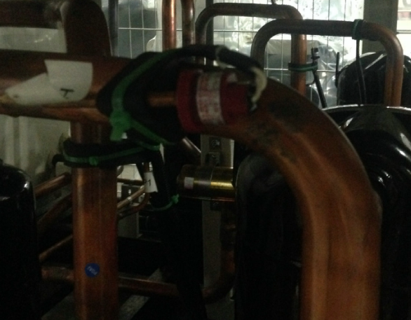
Step 2: check the outdoor fins the filter
Is the outdoor fins and indoor filters clogged? If so, clean them. If not, move to the next step.
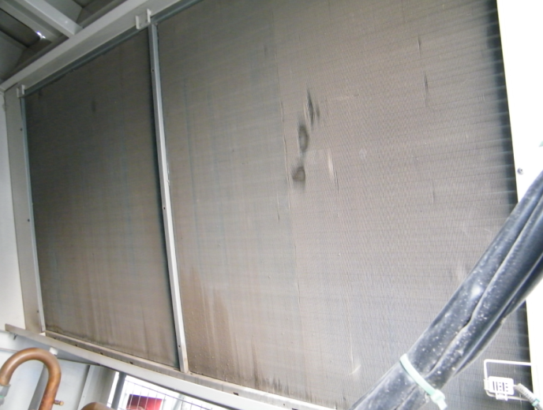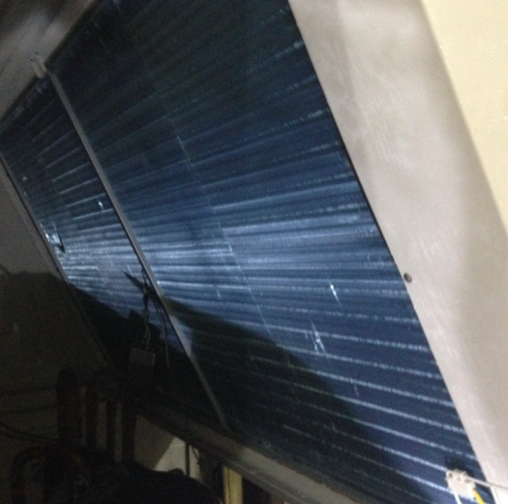
Dirty Fins Clean Fins
Step 3: check the fan
Start the unit manually and the compressor also will run. Then, see if the outdoor fan is started or not by testing the contact lead of the indoor fan with a clip-type ammeter. Normally, when all outdoor fans have been started, current of the indoor fan can be detected.
If the outdoor fan does not run or no current is detected for the indoor fan, test the resistance at two sides of the corresponding AC contactor inside the electric control box with a multi-meter. If it is infinite, it indicates the AC contactor is burnt out and please replace it.
According to the electric wiring, test resistance of the internal overload protector of the fan with a multi-meter. If it is infinite, it indicates the motor is overloaded and is allowed to be restarted until the motor is cooled. Then, test the winding resistance of the motor. If it is infinite, it indicates the motor is damaged and should be replaced.
Step 4: Check for the electrostatic expansion valve
Open the electric control cabinet and according to the electric wiring check if wiring of the drive board of the electrostatic expansion valve and setting of the DIP switch are correct or not? There are color and sequence requirements on wiring between the electrostatic expansion valve and the drive board. Besides, check if wiring at the terminal of the electrostatic expansion valve is loosened or not.
If so, correct it. If not, move to the next step.
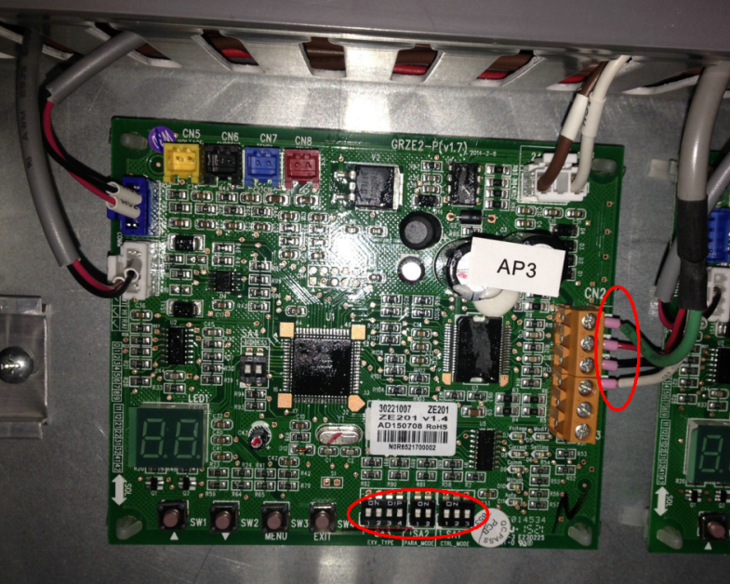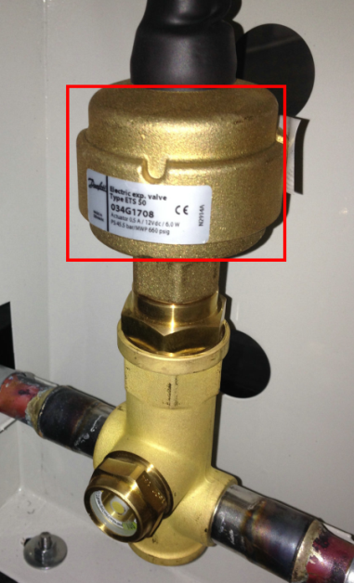
EXV Drive Board EXV
Repower the unit and observe if the electrostatic expansion valve is reset or not. Normally, resetting sound can be heard, and mechanical turning can be felt by touching it with the hand.
If no resetting sound is heard, knock the body of the electrostatic expansion valve with a hammer. Then, repower and observe if it can be reset or not. If not, replace it.

3.2 Compressor Low Pressure Protection
When low pressure protection occurs when the unit is just power on but not turned on, do troubleshooting as stated below.
Step 1: Check for the low pressure switch
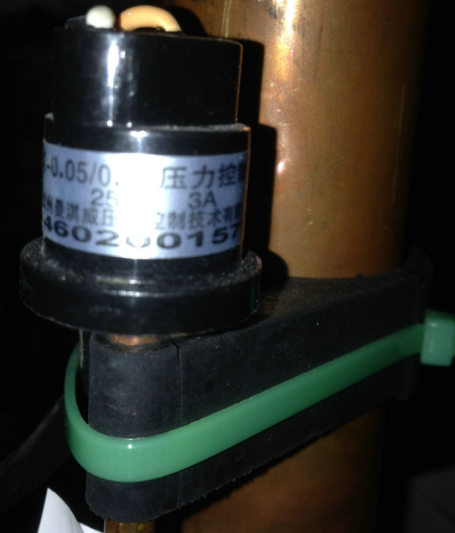
Low Pressure Switch
Is the connection between the lead and the pressure switch loosened or broken? If so, replace the pressure switch. Is the lead broken? If so, also replace the pressure switch.
Is the terminal of the pressure switch lead at the main board loosened? If so, reconnect it.
Test the resistance of two sides of the pressure switch. If the test result indicates the pressure switch is open, then it proves the pressure switch is satisfactory; if the test result indicates the pressure switch is closed, it proves the pressure switch is damaged.
Step 2: Check for refrigerant leakage
Connect a manometer at the charging port of the heat exchanger. If the saturation temperature corresponding to the system pressure is the same as the current ambient temperature, it indicates the refrigerant system is normal. If the system pressure is close to the atmospheric pressure or the saturation temperature corresponding to the test pressure is more than 10℃ lower than the current ambient temperature, it indicates refrigerant is inadequate, and please locate where the leakage is (leak test should be performed when the unit has stopped for at least one hour.)
Pay most attention to the process tube and the charging port.
1) Check if leak is caused by broken process tube (as shown in the figure below). If so, weld it again and recharge refrigerant.
2) Check if leak is caused by the charging port without the screw cap or loosened cap. If so, tighten it and then take the further check. Where no leak can be detected, recharge refrigerant.
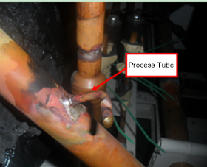
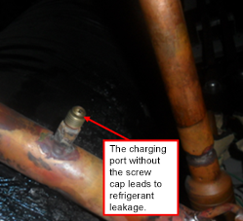

When low pressure protection occurs in operation, do troubleshooting as stated below.
Step 1: Check for the filter
Open the access door and check if the indoor filter is clogged or not. If so, clean it. If not, move to the next step.
Step 2: Check for wiring of the electrostatic expansion valve
Open the electric control cabinet and according to the electric wiring check if wiring of the drive board of the electrostatic expansion valve and setting of the DIP switch are correct or not? There are color and sequence requirements on wiring between the electrostatic expansion valve and the drive board. Besides, check if wiring at the terminal of the electrostatic expansion valve is loosened or not.
If so, correct it. If not, move to the next step.
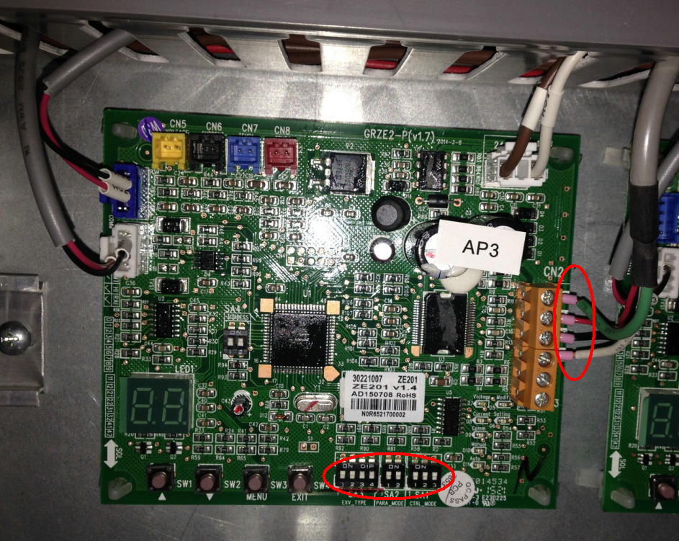
EXV Drive Board
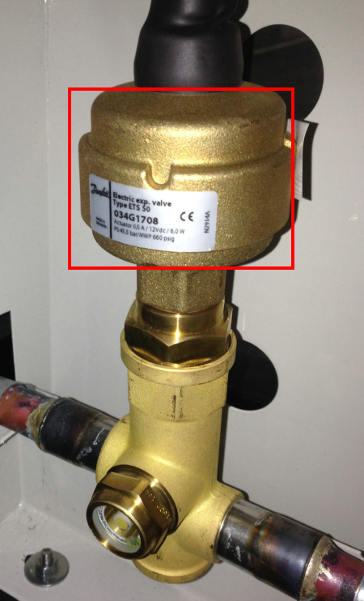
EXV
Step 3: Check for the electrostatic expansion valve
Repower the unit and observe if the electrostatic expansion valve is reset or not. Normally, resetting sound can be heard, and mechanical turning can be felt by touching it with the hand.
If no resetting sound is heard, knock the body of the electrostatic expansion valve with a hammer. Then, repower and observe if it can be reset or not. If not, replace it.
Step 4: Check for the temperature sensor
Open the access door and check the temperature sensor for the indoor fins. Is the temperature sensor insulated or not? If not, do it. If so, move to the next step.
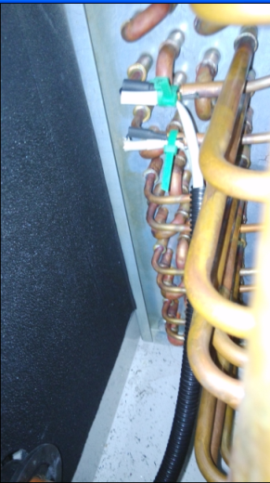
Liquid Line Temperature Sensor for the Indoor Fins
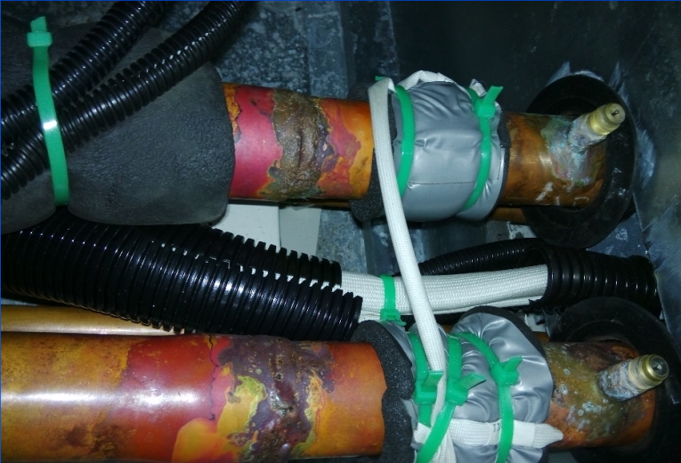
Vapor Line Temperature Sensor for the Indoor Fins
Is the temperature sensor for the outdoor fins insulated or not? If not, do it. If so, move to then next step.
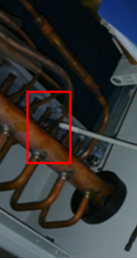
Liquid Line Temperature Sensor for the Outdoor Fins
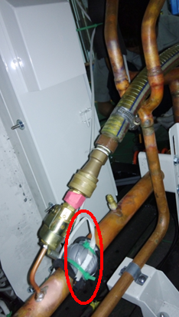
Vapor Line Temperature Sensor for the Outdoor Fins
Step 5: Check for refrigerant leakage
Connect a manometer at the charging port of the heat exchanger. If the saturation temperature corresponding to the system pressure is the same as the current ambient temperature, it indicates the refrigerant system is normal. If the system pressure is close to the atmospheric pressure or the saturation temperature corresponding to the test pressure is more than 10℃ lower than the current ambient temperature, it indicates refrigerant is inadequate, and please locate where the leakage is (leak test should be performed when the unit has stopped for at least one hour.)

3.3 Filter Pressure Differential Protection
Step 1: Check for the filter.
Open the access door and check the filter. Is the filter clogged or not? If so, clean it. If not, move to the next step.
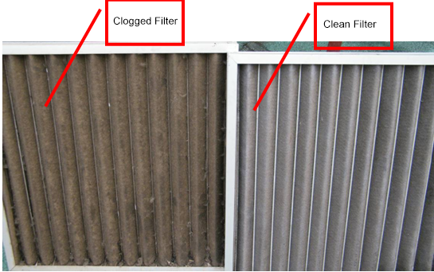
Step 2: Check for the valves at the return air duct
Are all valves at the return air duct closed or opened fully? If so, open them fully. If not, move to the next step.
Step 3: Check for locations for pressure measurement for the pressure differential switch
Check for locations for pressure measurement for the pressure differential switch. Location for the high pressure side is at front of the filter and location for the low pressure side is after the filter. Are locations correct or not? If not, correct it. If so, move the next step.
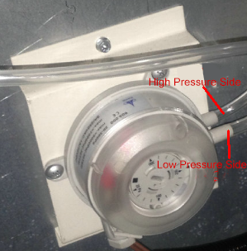
Pressure Differential Switch
Step 4: Check for wiring of the pressure differential switch
According to the wiring diagram, check for wiring of the pressure differential switch. Is the wiring correct? If not or loosened, correct it as per the wiring diagram. If so, move to the next step.
Step 5: Check for the pressure differential switch itself.
Draw hoses at two ends of the pressure differential switch out and make pressure at two ends keep balance.
Access to the air supply mode through the control panel and observe if the unit will come into pressure differential protection or not. If so, replace the pressure differential switch. If not, power off the unit and move to the next step.
Step 6: Check for the set point of the pressure differential switch
Check for the set point of the pressure differential switch. If it is less than 150pa, adjust it. If it is larger than 150pa, replace it.

4 Maintenance to Main Components

4.1 Requirements on Maintenance
The unit should be maintained by the qualified technician, who is responsible for checking routine operation, troubleshooting, and routine maintenance.
- Safety Requirements
(1) Be sure it is insulated between the maintainer and the equipment.
(2) Do not access to the equipment before the fan has stopped.
(3) Make sure each electric device and the main power supply is insulated before accessing to inside of the unit.
- Routine Operation
(1) All safety protection switches have been configured before delivery. Do not adjust or deactivate them randomly.
(2) When starting the unit initially or shut down for more than 24 hours, it should be preheated for at least 8 hours to avoid damaged caused for forced startup of the compressor.
(3) Do not put sundries on or around the unit and keep dry and good ventilation around the unit. When heavy dust is accumulated at the condenser fins, clean them so as to prevent the unit from shutdown or degraded performance.
(4) The fresh air damper should be closed when the unit stops for quite long times. Meanwhile, the fan belt should be loosened and lubrication should be done if necessary.
(5) When the unit comes into faults which the user fails to resolve, please contact the local after-sales agent.
(6) Do not frequently start or stop the unit deliberately.
- Maintenance to the Main Unit
Items stated below should be maintained once every 3-6 months. The actual period depends on environmental and use conditions.
(1) Check wiring and electric devices. Make sure all electric devices are reliable and wired securely and grounded correctly.
(2) Check for the bearing. Is it worn? Does refrigerant leaks? If so, add oil or replace the bearing.
(3) Check for tightness of the lock nuts or other bolts for the bearing.
(4) Check for the belt. If it skids, adjust it. If it is worn, replace it.
(5) Check for vibration of the fan. Does the vibration redactor work normally? Balance the fan dynamically if necessary.
(6) Check for temperature rise of the motor. If there is something unusual, figure out the cause and then repair or replace it.
(7) Check for the flexible connection at the air inlet/out. If it is damaged, replace it in time.
(8) Check for the heating coils. Clean it if necessary.
(9) Check for drain pan and clean it. If there is damage and rust, de-rust and repaint it.
(10) Check for sealing of all access doors. Can all doors be opened or closed flexibly? Lubricate the door hinge if necessary.
(11) Check for running status of each component; Check for pipe connectors and valves and see there is oil stain or not. Make sure there is no refrigerant leak. If so, contact the local after-sales agent and never do it yourself.

4.2 Maintenance to Main Components

4.2.1Maintenance to the Fan
Please cut off the main power supply when accessing to the fan.
(1) Check for motor, belt and belt pulley. Is they aligned? If not, correct it. Clean the belt with a dry cloth. No oil and grease is allowed on the surface of the belt. When replacing the belt, same type should be used. For correct installation, make sure reference planes of the belt pulleys at the same level.
(2) The belt should keep a proper tension to avoid the bearing to be prematurely used or worn. It can be checked with a tension-meter. (Note: do not keep the belt over tensioned; otherwise the bearing would be damaged. Generally, the optimized tension indicates the belt would not skid at the maximal load.
(3) The preload is usually controlled through a specified f which is produced by the vertical load G applied at the middle point of the belt, as shown in the figure below.
Generally, the applied G will produce 1.6mm deflection every 100mm, that is f=.
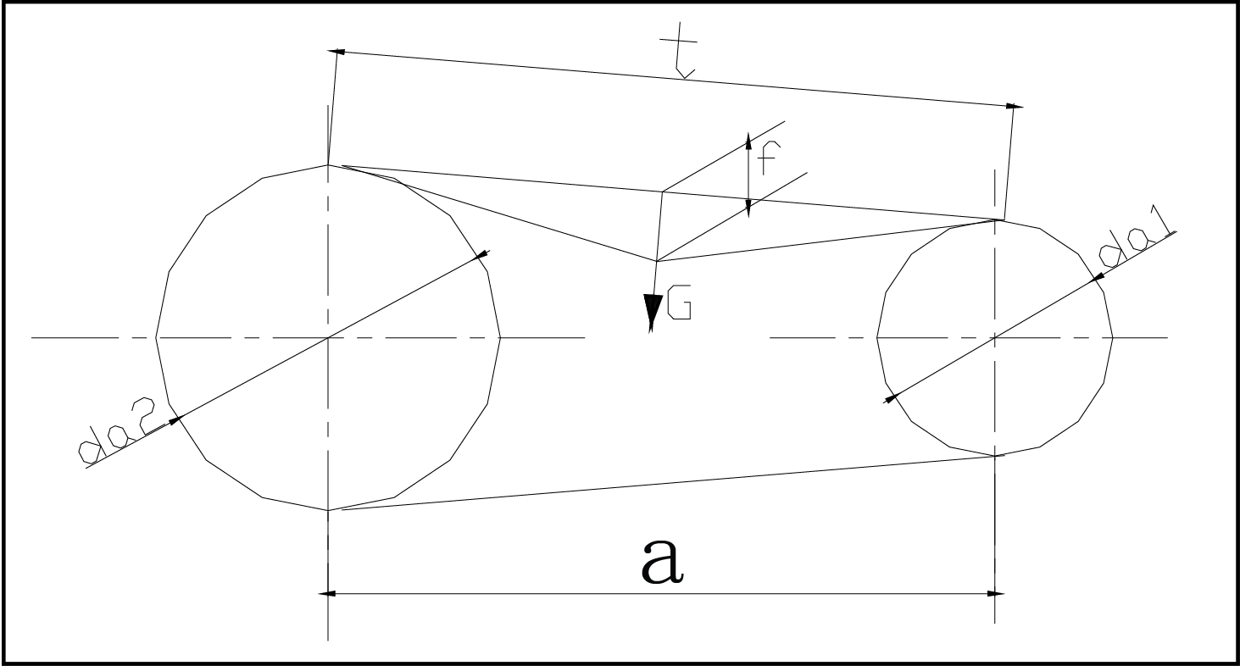
See the table below for the vertical force G for measurement of the preload. Among them, the upper limit is for the new belt or belt under high tension (like high speed, overloading startup, angle of contact, frequent high-torque startup etc.)
Vertical Force G for Measurement of the Preload
Unit: N
Belt Type |  | Diameter of the Smaller Belt Pulley (mm) | Belt Velocity v(m/s)
 |  |  | 0~0 | 10~0 | 20~30
Narrow v Belt | SPZ | 67～95 | 9.5～14 | 8～13 | 6.5～11
 |  | >95 | 14～21 | 13～19 | 11～18
 | SPA | 100～140 | 18～26 | 15～2L | 12～18
 |  | >140 | 26～38 | 21～32 | 18～27

4.2.2Maintenance to the Fins
Check for fins periodically.
Fins can be cleaned with sprayed compressed air, vapor or water along the opposite direction with the normal air flow. If it is too dirty, detergent can be used. When the unit has run for about two years, overall cleaning is required. Scaling inside the coil can be cleaned chemically and fins can be flushed with water.
See cleaning steps as stated below.
  - Cut off the main power supply
  - Wrap all terminals with water-proof plastic bags to prevent water from entering.
  - Flush fins along the opposite direction with the air inlet direction with high-pressure gas or running water. During flushing, the gas or water flow should be kept vertical with fins to prevent fins tipping.
  - When the original cover of fins is visual or water flows down along the fins, it indicates fins have been cleaned. Besides, check for drain pan. If necessary, clean it. The condensate outlet should be kept unobstructed so as to drain it favorably.

4.2.3Maintenance to the Filter
The filter is a key component to keep the air quality. Filters used for the rooftop packaged unit are moisture-proof.
  - Check for the filter periodically. If it is too dirty, clean or replace it. Cleaning times is limited. Once it is expired, do replace it. The cleaned filter can be used only when it is dry enough.
  - Check for connection between the filtering media and the casing for frame. Make sure connection is secure and there is no leakage or disconnection. If there is, replace it.
  - The filter should be handled carefully.

5 Replacement of Components

5.1 Replacement of the Fan Bearing
  - Remove anti-rust paint at the bearing with the sand cloth.
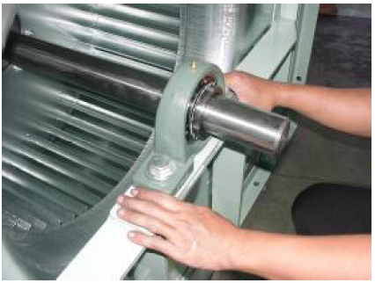
  - Loosen the curved plate at the lock washer.
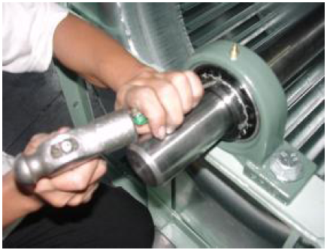
  - Loosen the lock nut form the taper sleeve.
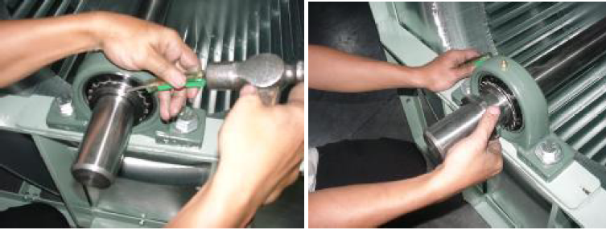
  - Reverse and install the lock nut at the taper sleeve.
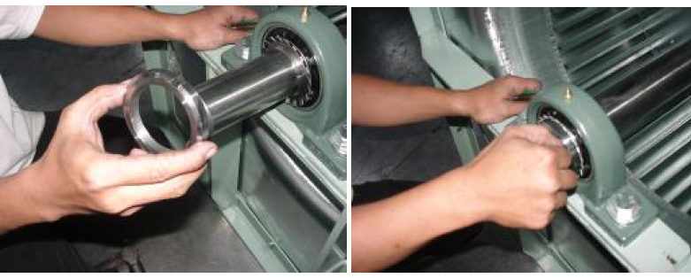
  - Hammer the taper sleeve via a wooden block from outside to inside. 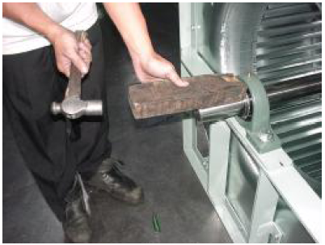
  - Loosen the fixing screw of the bearing and take out the screw bolt. 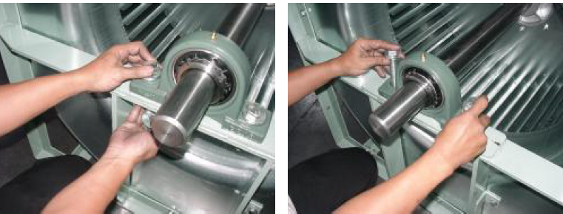
  - Take out the bearing.
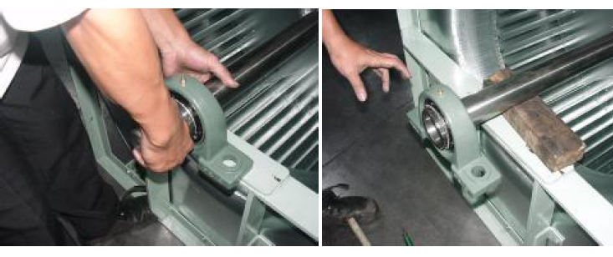
  - Prepare the UKP bearing, taper sleeve, lock washer, lock nut, fixing bolt and screw.
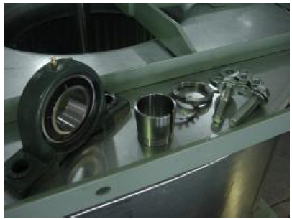
  - Put the bearing on the shaft.
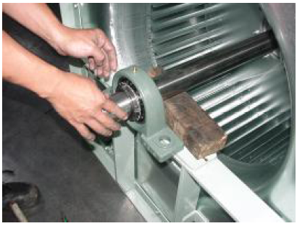
  - Tighten the fixing bolt and screw at the support board of the bearing.
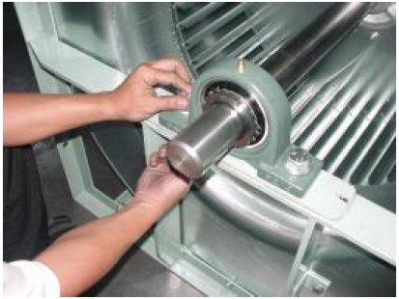
  - Measure length of the projecting shaft at two sides. Keep it the same.
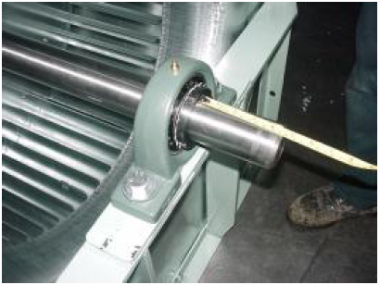
  - Hammer the sleeve tape from inside to outside and meanwhile tighten the lock unit with hand until it is tight enough.
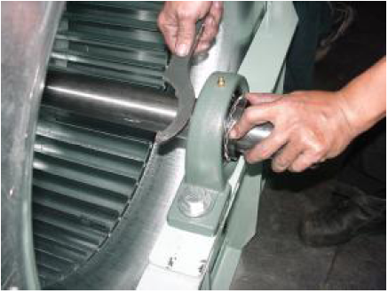
  - Adjust the torque wrench.
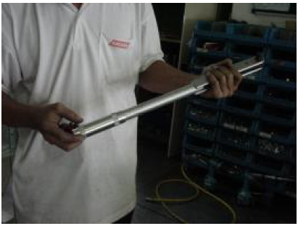
  - Lock the bearing with the torque sleeve.
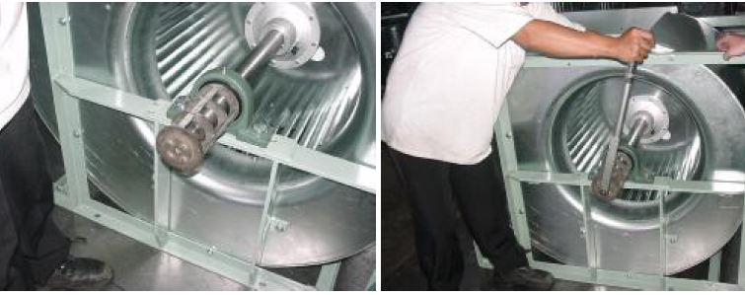
  - Mark the confirmed angle.
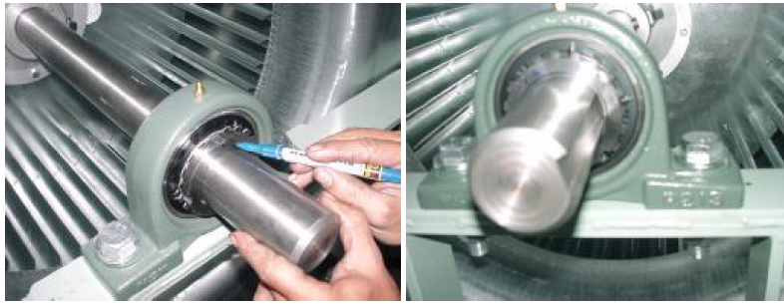
  - Turn the lock nut with the hook spanner to the target angle.
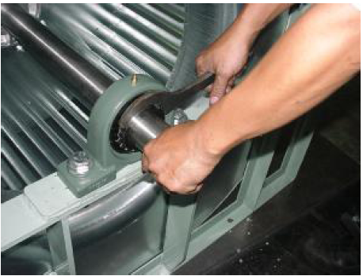
  - Hammer one tooth at the lock washer into the groove of the lock nut so as to fix it. Never loosen the lock nut for hammering the teeth into the groove.
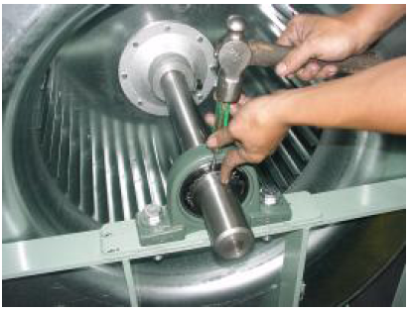

5.2 Replacement of the Motor Bearing
- Tools for disassembling the bearing: wrenches, external pliers, screw drivers, crow bars, hammers, hydraulic elongator
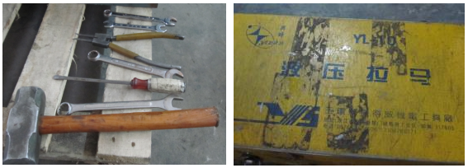
- Disassembling Steps of the Bearing at the End with the Shaft Extension
  - Put the straight screw driver against the gap between the flat key and the bearing head face and the screw driver should keep an upward angle of elevation. Then, hammer the flat key out.
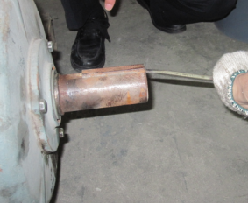
  - Loosen the preloaded bolt at the bearing cap and then pry open the bearing cap with a crow bar.
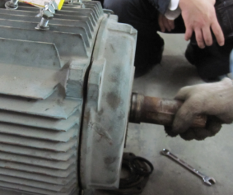 | 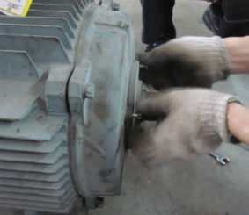
Note: When prying the bearing cap, apply force evenly with two hands 180° separated
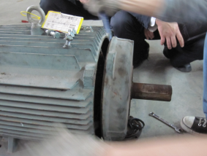
Take away the bearing cap.
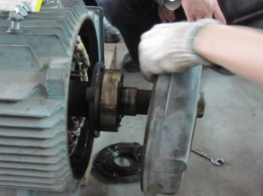
  - Take out the clamp spring.
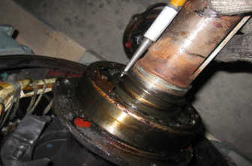
  - The inner cap comes out and then let the hydraulic elongator seize the outer ring of the bearing.
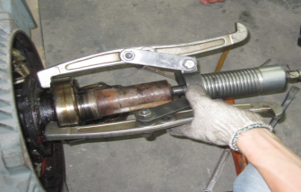
  - Preload the hydraulic elongator and see if it can keep balanced or not.
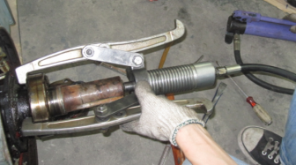
  - Adjust the hydraulic elongator and then cold draw the bearing. When a sudden sound is heard, it indicates the bearing is loosened. Then, pressurize the hydraulic elongator until the bearing is out.
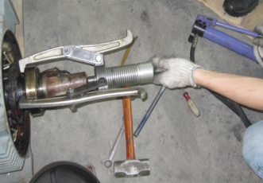
  - Draw out the bearing.

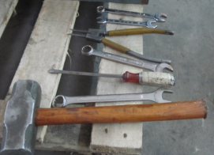 | 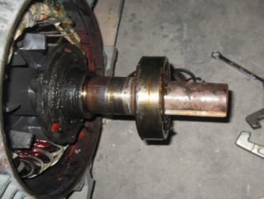
- Disassembling at the End without the Shaft Extension
It is same as that for the bearing with the shaft extension, but the fan blades or motor should be disassembled. For the self-cooled fan, fan blades should be disassembled, as shown in the figure below. That is, take out the clamp spring with the external pliers, hold the keyway with a crow bar and then knock them out slightly.
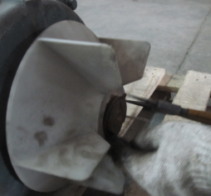
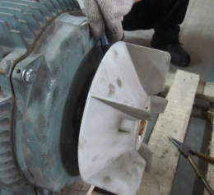
- Precautions for Disassembling
In order to keep proper axial clearance, spring shims are always used at the end without the shaft extension. During disassembling, keep them properly.
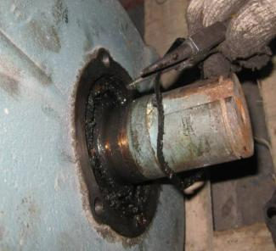
- Assembling of the Bearing
- Place the bearing at the proper location and make a soft metal rectangular rod against the inner ring of the bearing and then knock it circularly. After the bearing is slightly preloaded, check for its location, levelness and parallelism.
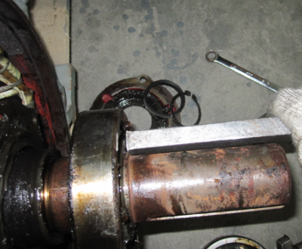
- Pillow the bearing to be replaced with a used one and then knock the inner ring with the soft metal rectangular rod until the bearing is placed rightly.
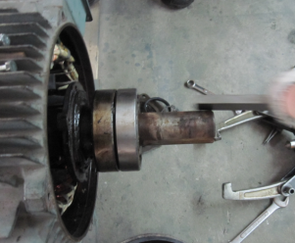
- Clean both inner and outer caps and lubricate them with oil filling 100% of the bearing and 1/2 of the inner and outer caps.
- Make the inner cap contact the bearing tightly.
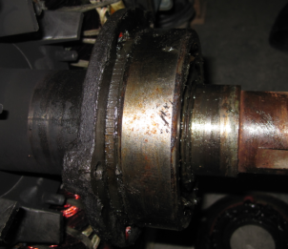
- Install the end cap of the motor.
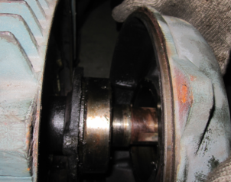
- Hammer the reinforcement part outside of the end cap slightly and evenly until the end cap is at the right place.
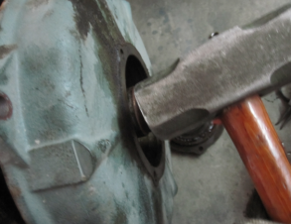
- Center it with the bolts of the bearing cap. If there is deviation between the inner cap of the bearing and the bolt hole of the end cap, rotate the end cap with one hand and correct the bolt hole with the other hand. Then, preload it properly.
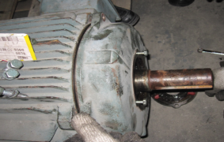
- Install the end cap of the motor and preload it and the motor base after it has been aligned. Note: all bolts should be preloaded evenly but not one by one.
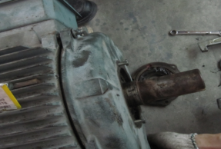
- Take down the bolts for alignment and install the bearing cap.
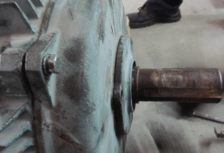
- Place a sleeper on the shaft extension and hammer it to release the assembly stress.
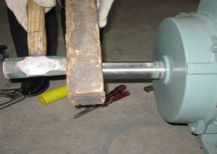
Note: for the sealing bearing, steps above also can be taken for reference but without installation of the bearing cap, as shown in the figure below.
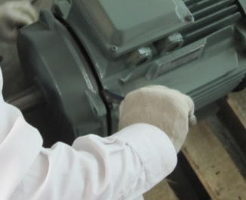
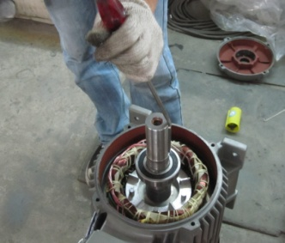

5.3 Lubricating
As one of the key components of the motor and fan, it will directly affect operating noise, load and current.
Normal operation of the bearing has some requirements on the environment. That is, the bearing should be kept clean and no dust and water will enter. Air inlet and outlet should be kept unobstructed and the air hood should be cleaned frequently.

5.3.1 Principles for Lubricating
- Generally, the bearing should be lubricated periodically.
- For the double-seal bearing of the small-sized motor, oil has been charged in advance and no more oil is required.
- For the large-sized motor (H280 or above) and motor with special requirement, they are equipped with the oil charging and discharge devices. Although they have been oil charged before delivery but lubricating oil should be replaced periodically. The replacement frequency depends on size and use condition of the motor.

Table 1 Lubricating Period for the Motor
Rated Power  (kW) | Motor Speed  RPM | Lubricating Period
 |  | Normal Condition | Extreme Conditions | Severe Conditions
＜18.5 | 1500 | 5 years | 3 years | 1 year
18.5~90 | 1500 | 1 year | 6 months | 3 months
90~200 | 1500 | 3 months | 3 months | 1 month
200~630 | 1500 | 3 months | 1 month | 15 days
＜18.5 | 3000 | 5 years | 3 years | 1 year
18.5~90 | 3000 | 1 year | 6 months | 3 months
90~200 | 3000 | 3 months | 3 months | 1 month
200~630 | 3000 | 3 months | 1 month | 15 days
Note: Over-lubricating or too frequent lubricating would make the motor damaged.
Table 2 Lubricating
Operating Temperature |  | Lubricating Period |  |  | Bearing Type | Lubricating Oil
Above | Below | Normal Conditions | Extreme Condition | Severe Condition
Normal temp | 50 | 3 months | 2 months | 1 month | Cold-proof D2KI | SH33M
Normal temp | 50 | / | 1 year | 4 months | Common
50 | 70 | 1 year | 4 months | 1 month
70 | 100 | 6 months | 2 months | 2 weeks
100 | 120 | 2 months | 2 weeks | 5 days | Heat-proof D1K2 | SH44M
120 | 150 | 2 weeks | 5 days | 2 days
150 | 180 | 1 week | 2 days | 1 days
Note: Values listed the table above are just for reference. Different manufacturers may give difference requirements. Water covered in the User’s Manual always prevails.

5.3.2. Lubricating Steps
Step 1: Open the cover at the charging port and be sure the charging mouth is clean. Then, charge oil with the oil gun until it overflows.
  - Only clean tools are allowed to be used, as pollutants would enter inside of the bearing and then lead to unusual noise or damage.
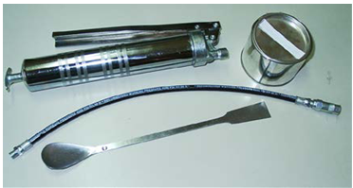
  - Clear away dirt around the charging port thoroughly.
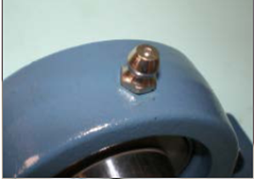
  - Connect the oil gun with the charging port. During charging, lf oil leaks, do some adjustment. Recharge it until leas is eliminated.
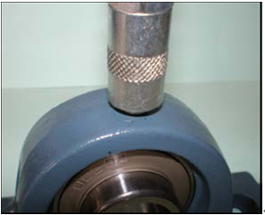
Note: during charging, turn the shaft so as to make one side of the bearing run with low speed and the other side being lubricated. In this way, oil can evenly be charged into the inside of the bearing.
Step 2: Take away the oil gun and let the motor run for 10~20 minutes. Put the cover of the charging port back when it is confirmed that excess oil has been discharged.
Note: Oil with correct type should be charged. Oil type is specified by the manufacturer. Once the newly charged oil is incompatible with the original, it will shorten service life of the bearing greatly.

6 Operation Conditions
Cooling: ambient temperature from18 to 48℃
Heating: ambient temperature from -15 to 24℃

GREE ELECTRIC APPLIANCES, INC. OF ZHUHAI
Add: West Jinji Rd, Qianshan, Zhuhai, Guangdong, China, 51900
Tel: (+86-567) 8522218, Fax: (+86-756) 8669426
E-mail: gree@gree.com.cn www.gree.com
For continuous improvement in the products, Gree reserves the right to modify the product specification and appearance in this manual without notice and without incurring any obligation.
JF00302968

